Wavy Closed Curved Shapes
# Source: AI Source: Provided by: [Data Path: Persons Table -> ID Column: 1, Name_En Column: Motasem Essam] -> From: [ChatGPT] on [7/25/2026]
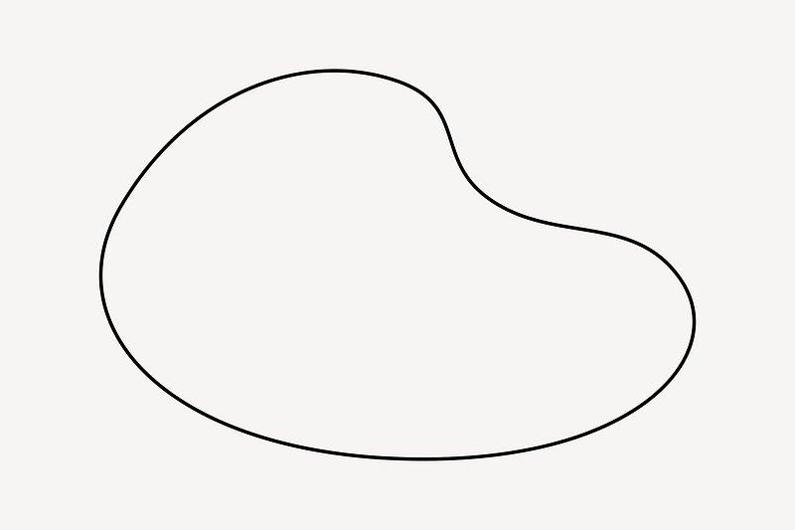
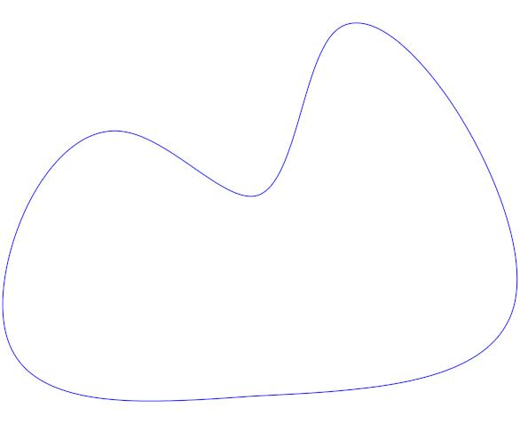
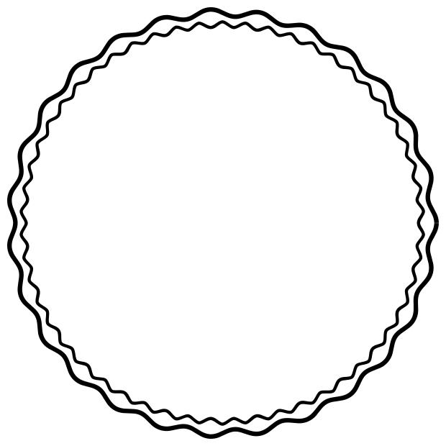
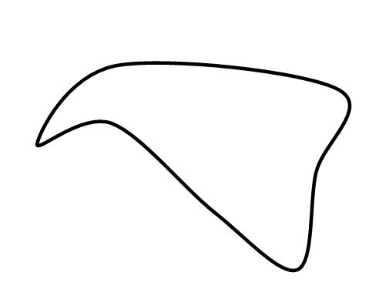
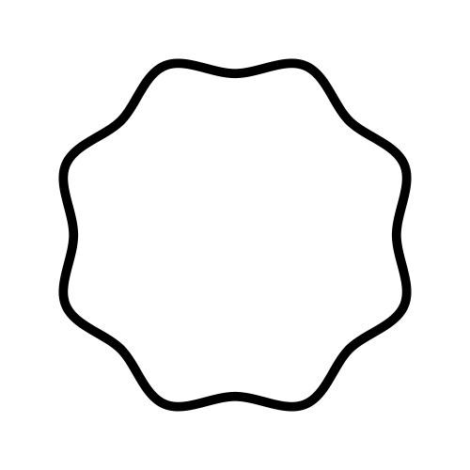

Definition
# Source: AI Source: Provided by: [Data Path: Persons Table -> ID Column: 1, Name_En Column: Motasem Essam] -> From: [ChatGPT] on [7/25/2026]
A Wavy Closed Curved Shape is a closed curved shape whose boundary contains repeated or varying wave-like undulations while remaining completely closed.
In simple terms:
It is a closed boundary that repeatedly curves inward and outward in a wave-like pattern.
$$\boxed{\text{Wavy Closed Curved Shape}=\text{Closed}+\text{Curved}+\text{Undulating Boundary}}$$
Unlike a circle or ellipse, its curvature is not necessarily constant or governed by a simple standard equation.

Characteristics
# Source: AI Source: Provided by: [Data Path: Persons Table -> ID Column: 1, Name_En Column: Motasem Essam] -> From: [ChatGPT] on [7/25/2026]
A wavy closed curved shape typically:
- Is closed.
- Has no open endpoints.
- Encloses a bounded region.
- Has a continuous curved boundary.
- Contains one or more waves, bulges, or undulations.
- May have regular or irregular waves.
- May be symmetric or asymmetric.
- May have constant or variable amplitude.
- May have constant or variable wavelength.
- Has no sharp vertices in its pure curved form.
The defining closed condition is:
$$\boxed{P_{\text{start}}=P_{\text{end}}}$$

Types of Wavy Closed Curved Shapes

1. Regular Wavy Closed Curves
# Source: AI Source: Provided by: [Data Path: Persons Table -> ID Column: 1, Name_En Column: Motasem Essam] -> From: [ChatGPT] on [7/25/2026]
A regular wavy closed curve has repeated undulations that follow a consistent pattern.
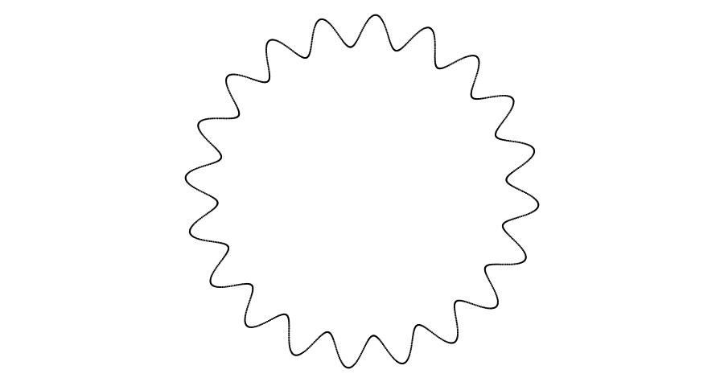
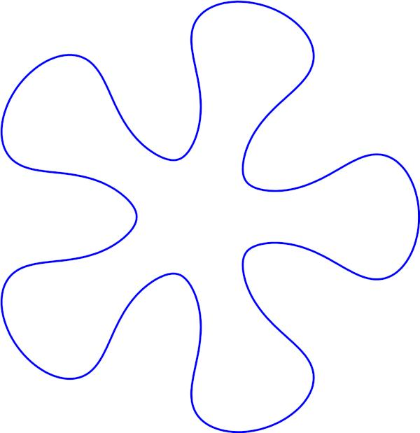
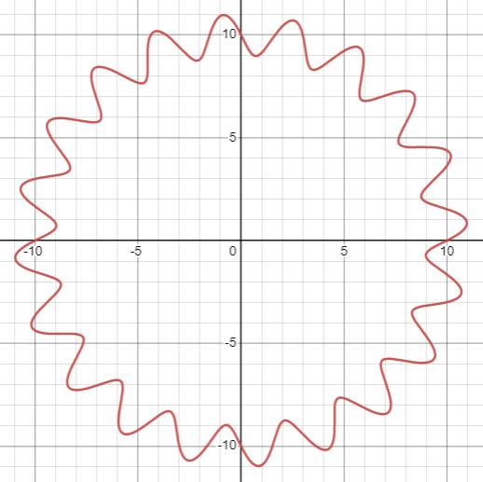
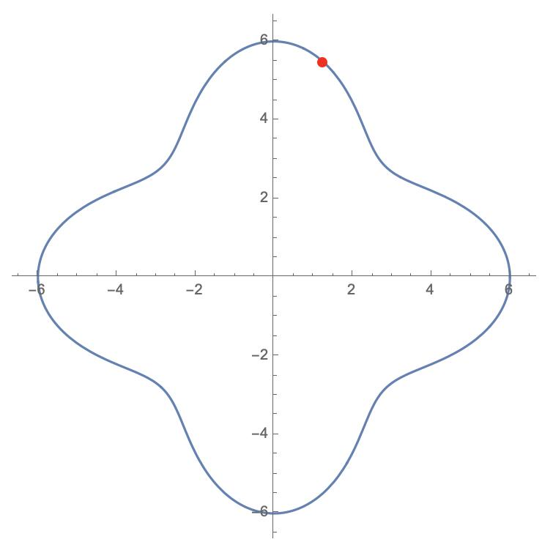
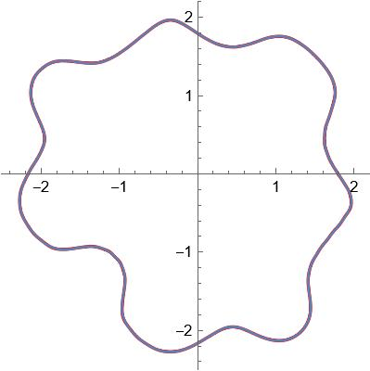
The waves may have approximately equal:
- Amplitudes.
- Wavelengths.
- Spacing.
- Curvature.
A periodic representation can be based on:
$$y=A\sin\left(kx\right)$$
although a closed shape requires the curve to eventually connect back to its starting point.

2. Irregular Wavy Closed Curves
# Source: AI Source: Provided by: [Data Path: Persons Table -> ID Column: 1, Name_En Column: Motasem Essam] -> From: [ChatGPT] on [7/25/2026]
An irregular wavy closed curve has waves of different sizes, spacing, or curvature.
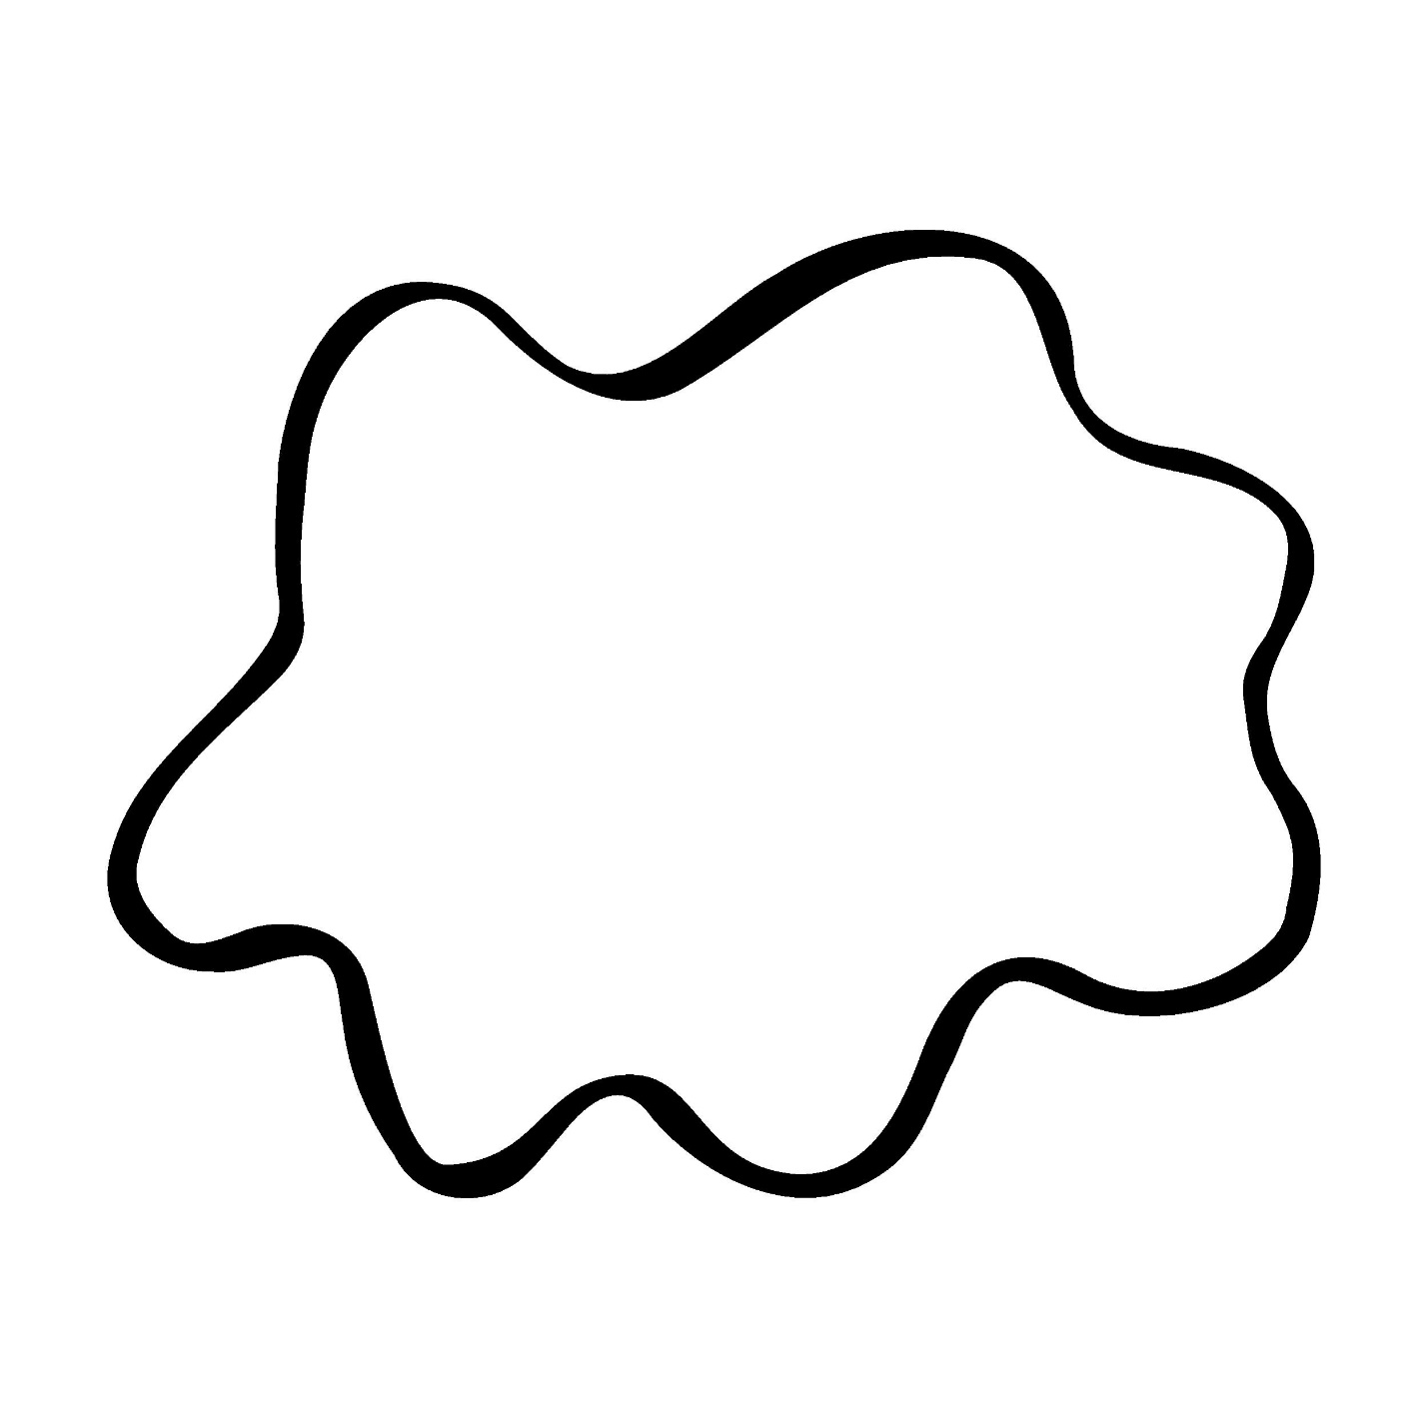
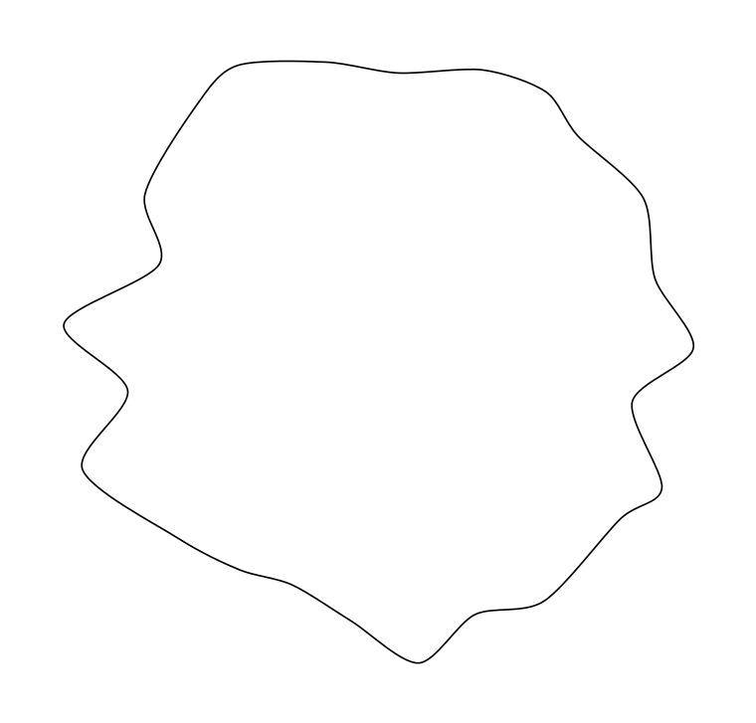
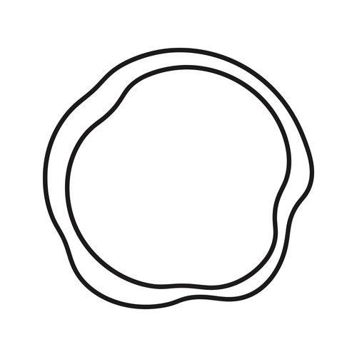
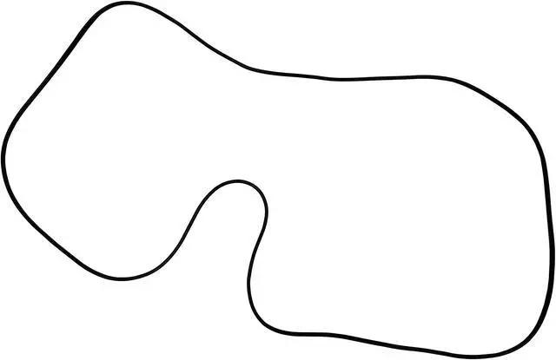
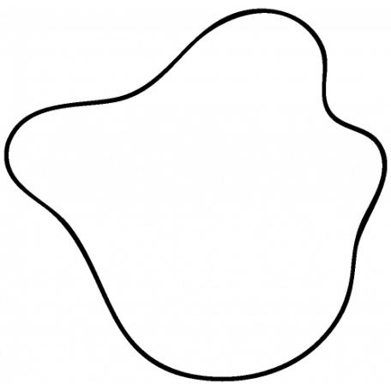
For example:
- Large wave followed by small wave.
- Unequal spacing between waves.
- Variable curvature.
- Different depths of inward undulations.
This is particularly useful as a subtype within your Irregular Closed Curves classification.

3. Symmetric Wavy Closed Curves
# Source: AI Source: Provided by: [Data Path: Persons Table -> ID Column: 1, Name_En Column: Motasem Essam] -> From: [ChatGPT] on [7/25/2026]
A symmetric wavy closed curve has repeated waves arranged symmetrically around one or more axes.
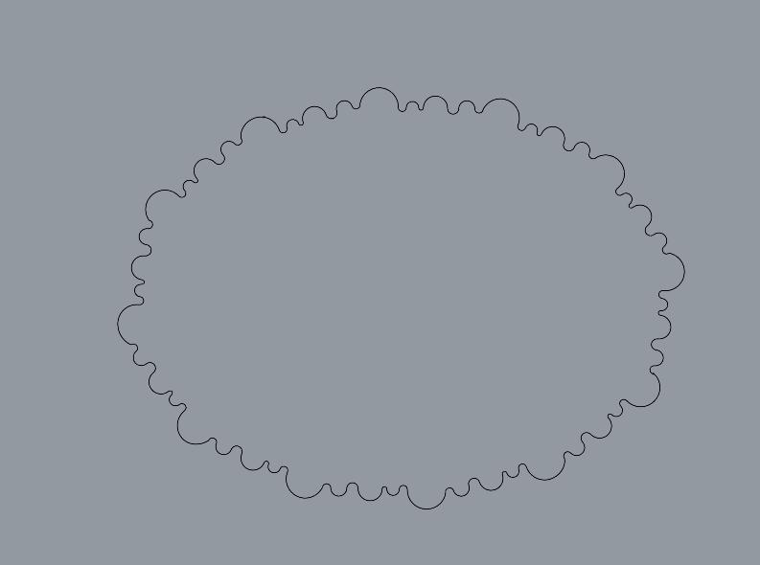
Possible symmetry includes:
- Vertical reflection symmetry.
- Horizontal reflection symmetry.
- Rotational symmetry.
The waves may be repeated around the entire boundary.

4. Asymmetric Wavy Closed Curves
# Source: AI Source: Provided by: [Data Path: Persons Table -> ID Column: 1, Name_En Column: Motasem Essam] -> From: [ChatGPT] on [7/25/2026]
An asymmetric wavy closed curve has uneven wave patterns and lacks regular symmetry.
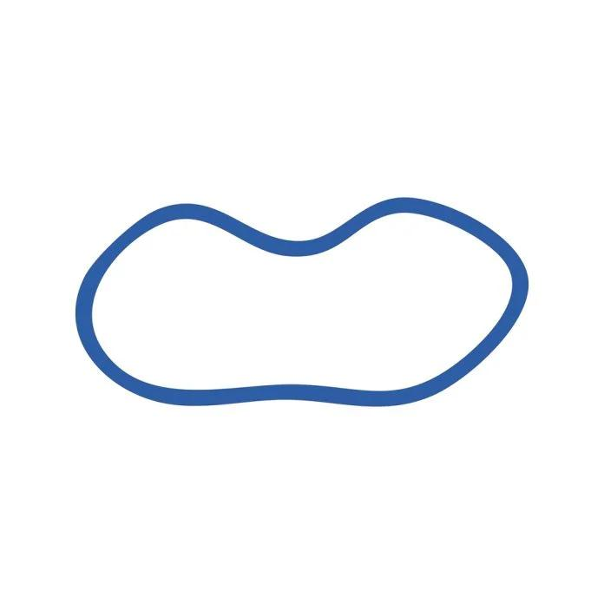
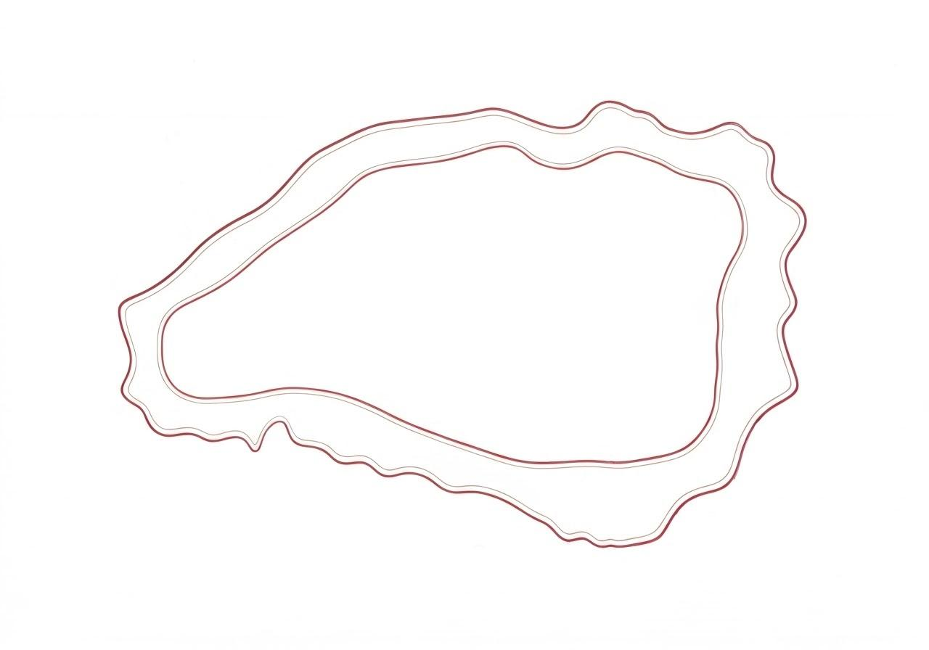
Different parts of the boundary may have different:
- Wave heights.
- Wave widths.
- Curvature.
- Number of undulations.

5. Smooth Wavy Closed Curves
# Source: AI Source: Provided by: [Data Path: Persons Table -> ID Column: 1, Name_En Column: Motasem Essam] -> From: [ChatGPT] on [7/25/2026]
A smooth wavy closed curve has gradual transitions between outward and inward curvature.
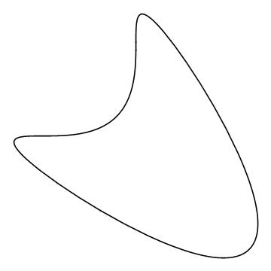
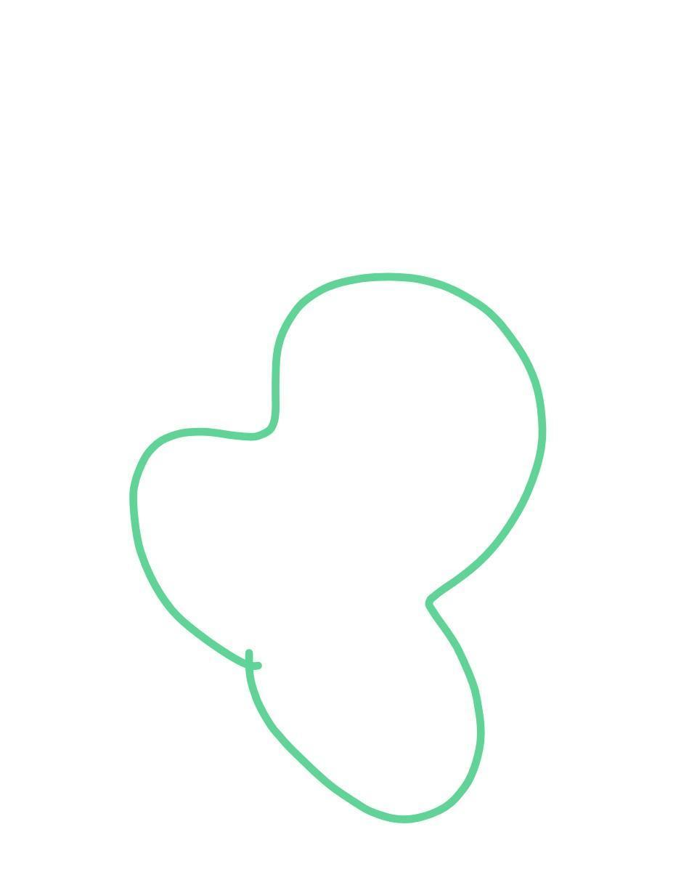
There are no sharp corners or sudden changes in direction.
This type can be considered a smooth freeform closed curve with undulations.

6. Lobed Wavy Closed Curves
# Source: AI Source: Provided by: [Data Path: Persons Table -> ID Column: 1, Name_En Column: Motasem Essam] -> From: [ChatGPT] on [7/25/2026]
A lobed wavy closed curve has rounded outward bulges separated by inward curves.
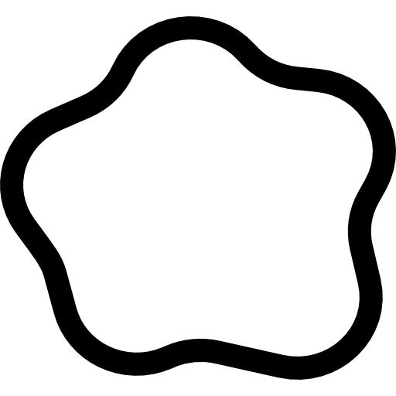
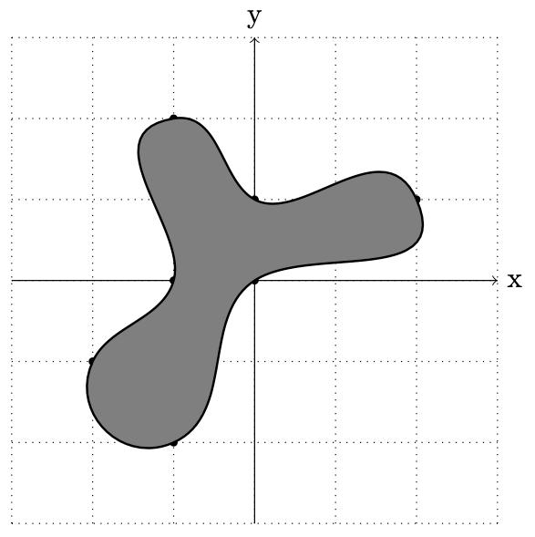
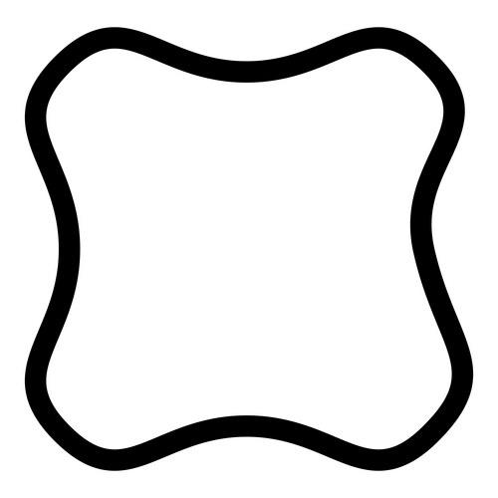
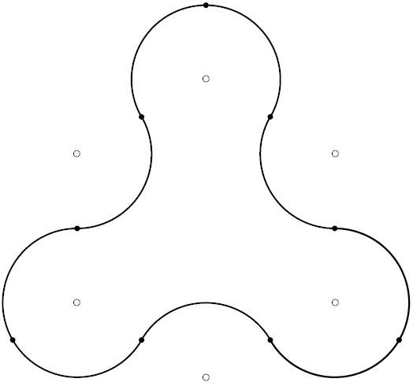
The lobes may be:
- Equal.
- Unequal.
- Symmetrical.
- Irregular.
For example, a flower-like outline with rounded lobes can be classified as a lobed wavy closed curve.

7. Concentric Wavy Closed Curves
# Source: AI Source: Provided by: [Data Path: Persons Table -> ID Column: 1, Name_En Column: Motasem Essam] -> From: [ChatGPT] on [7/25/2026]
Multiple wavy closed curves can be arranged around approximately the same center.
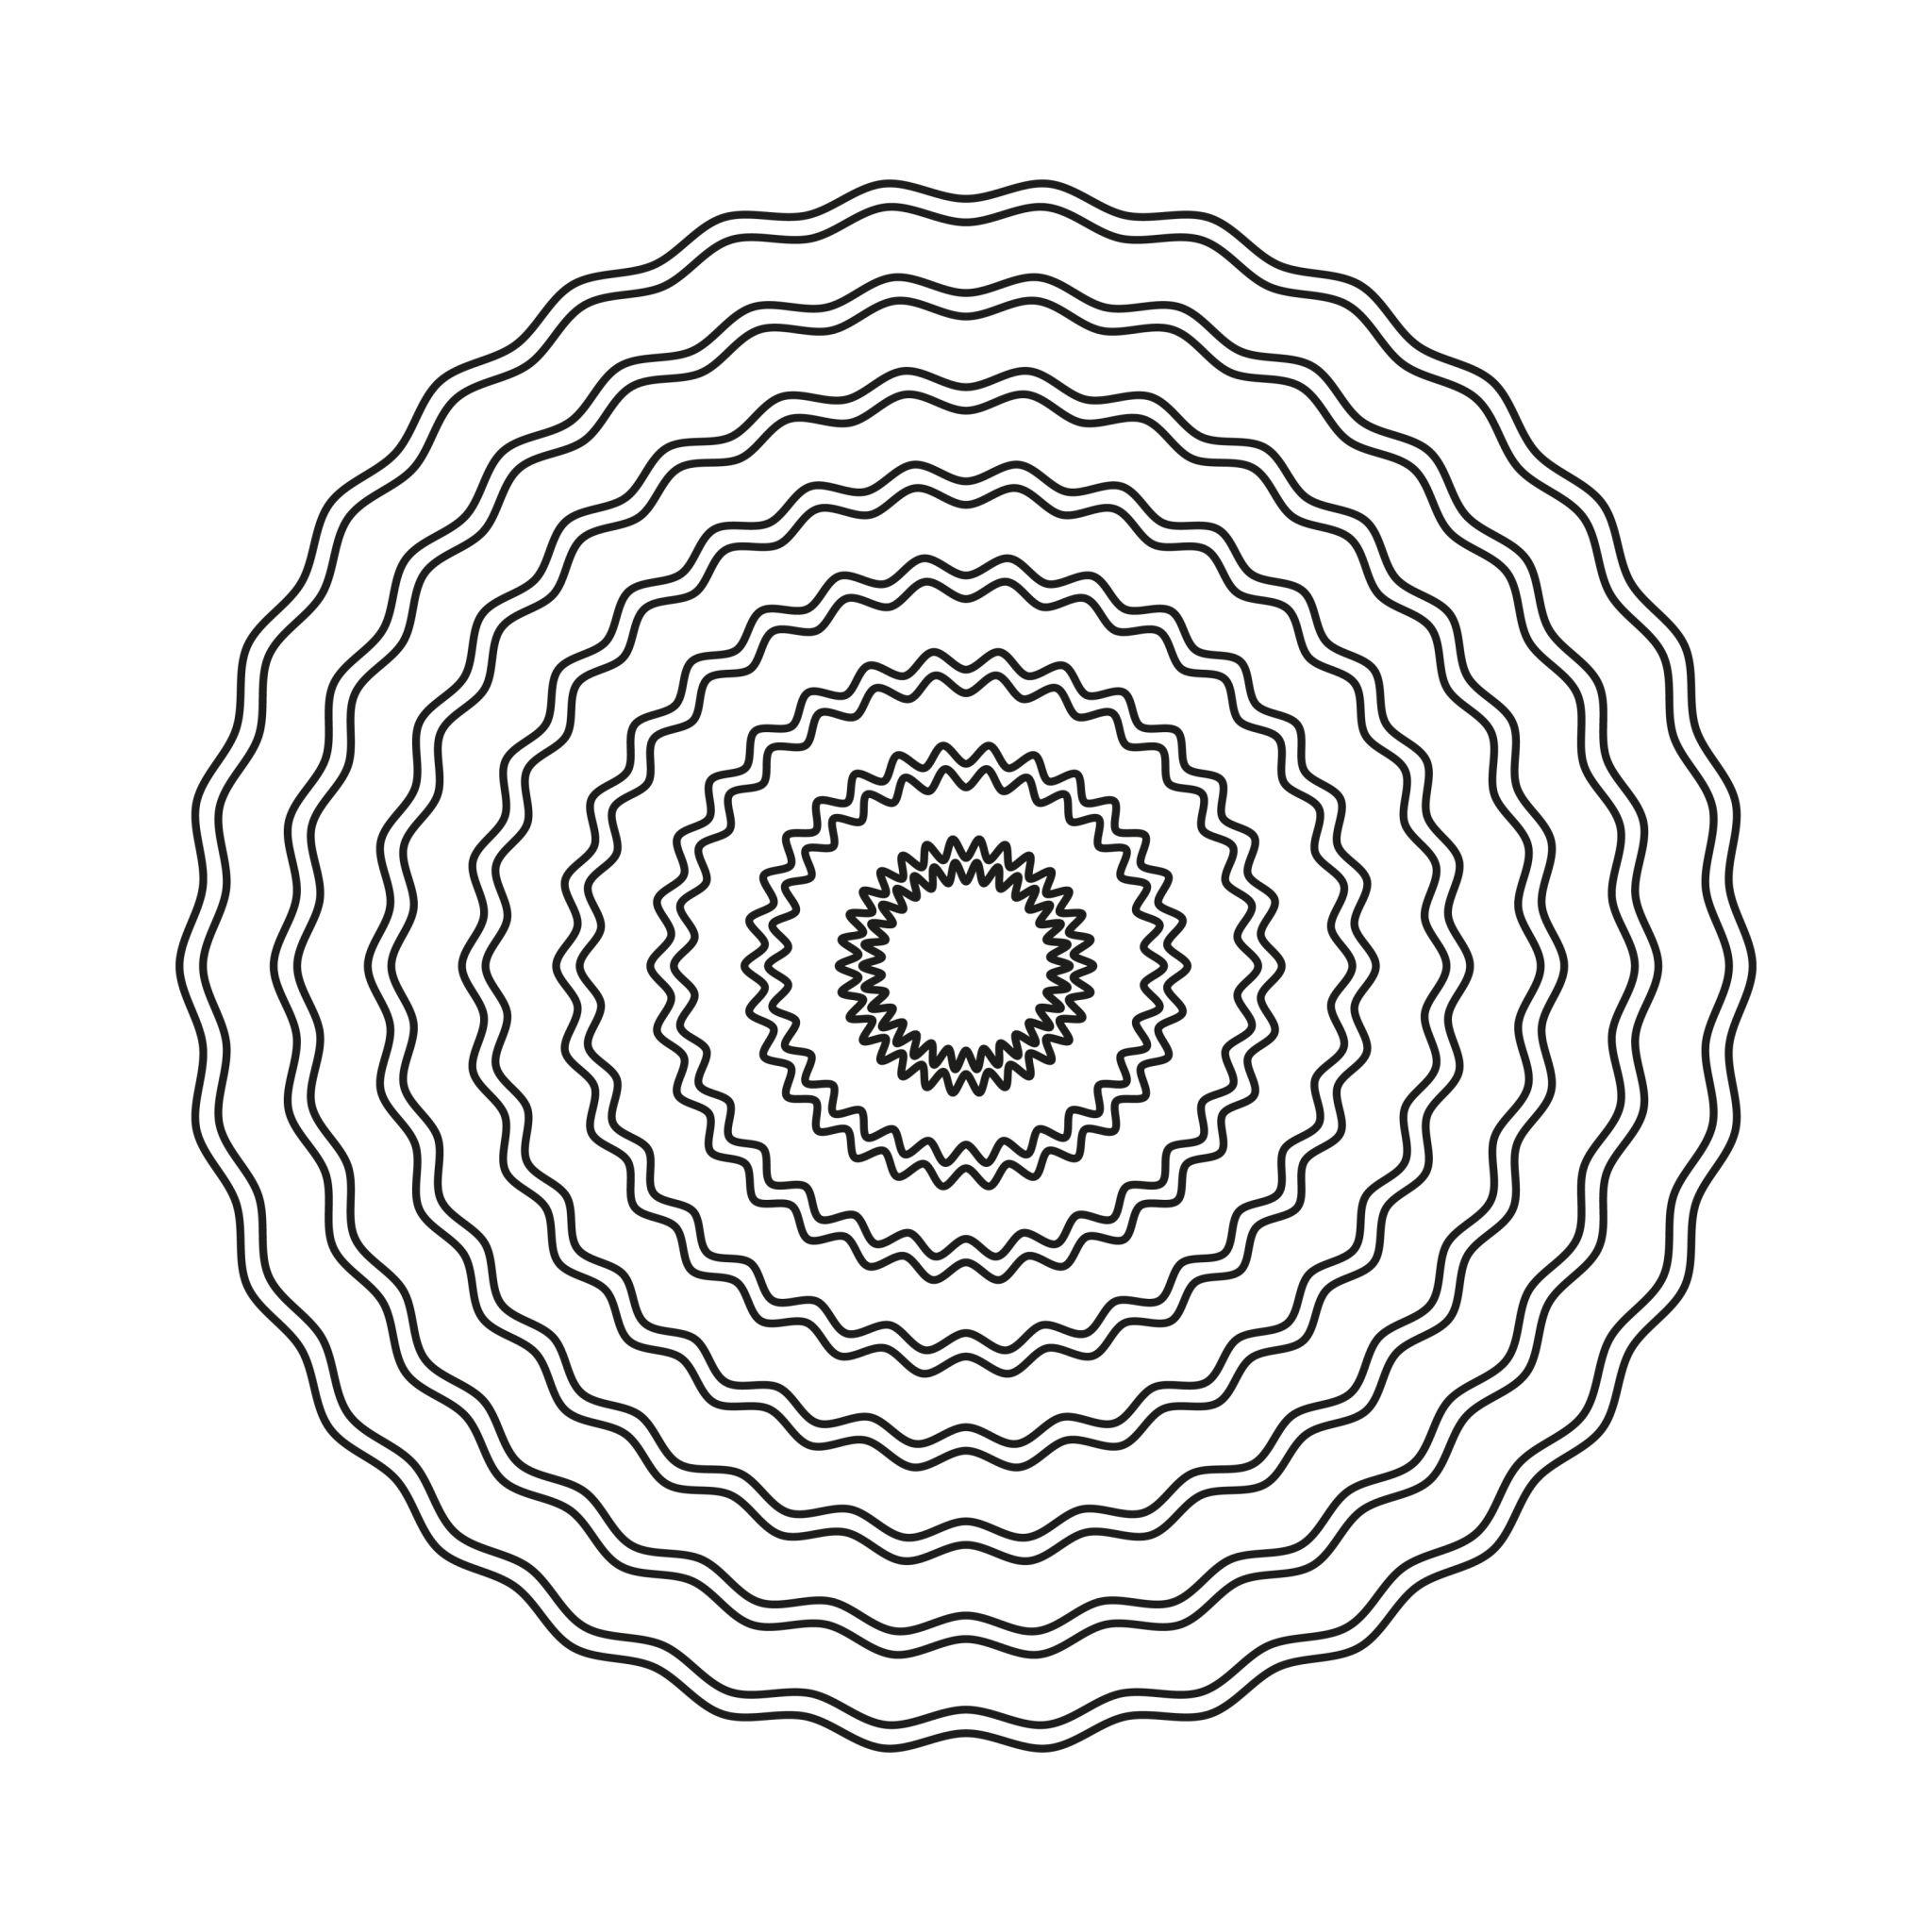
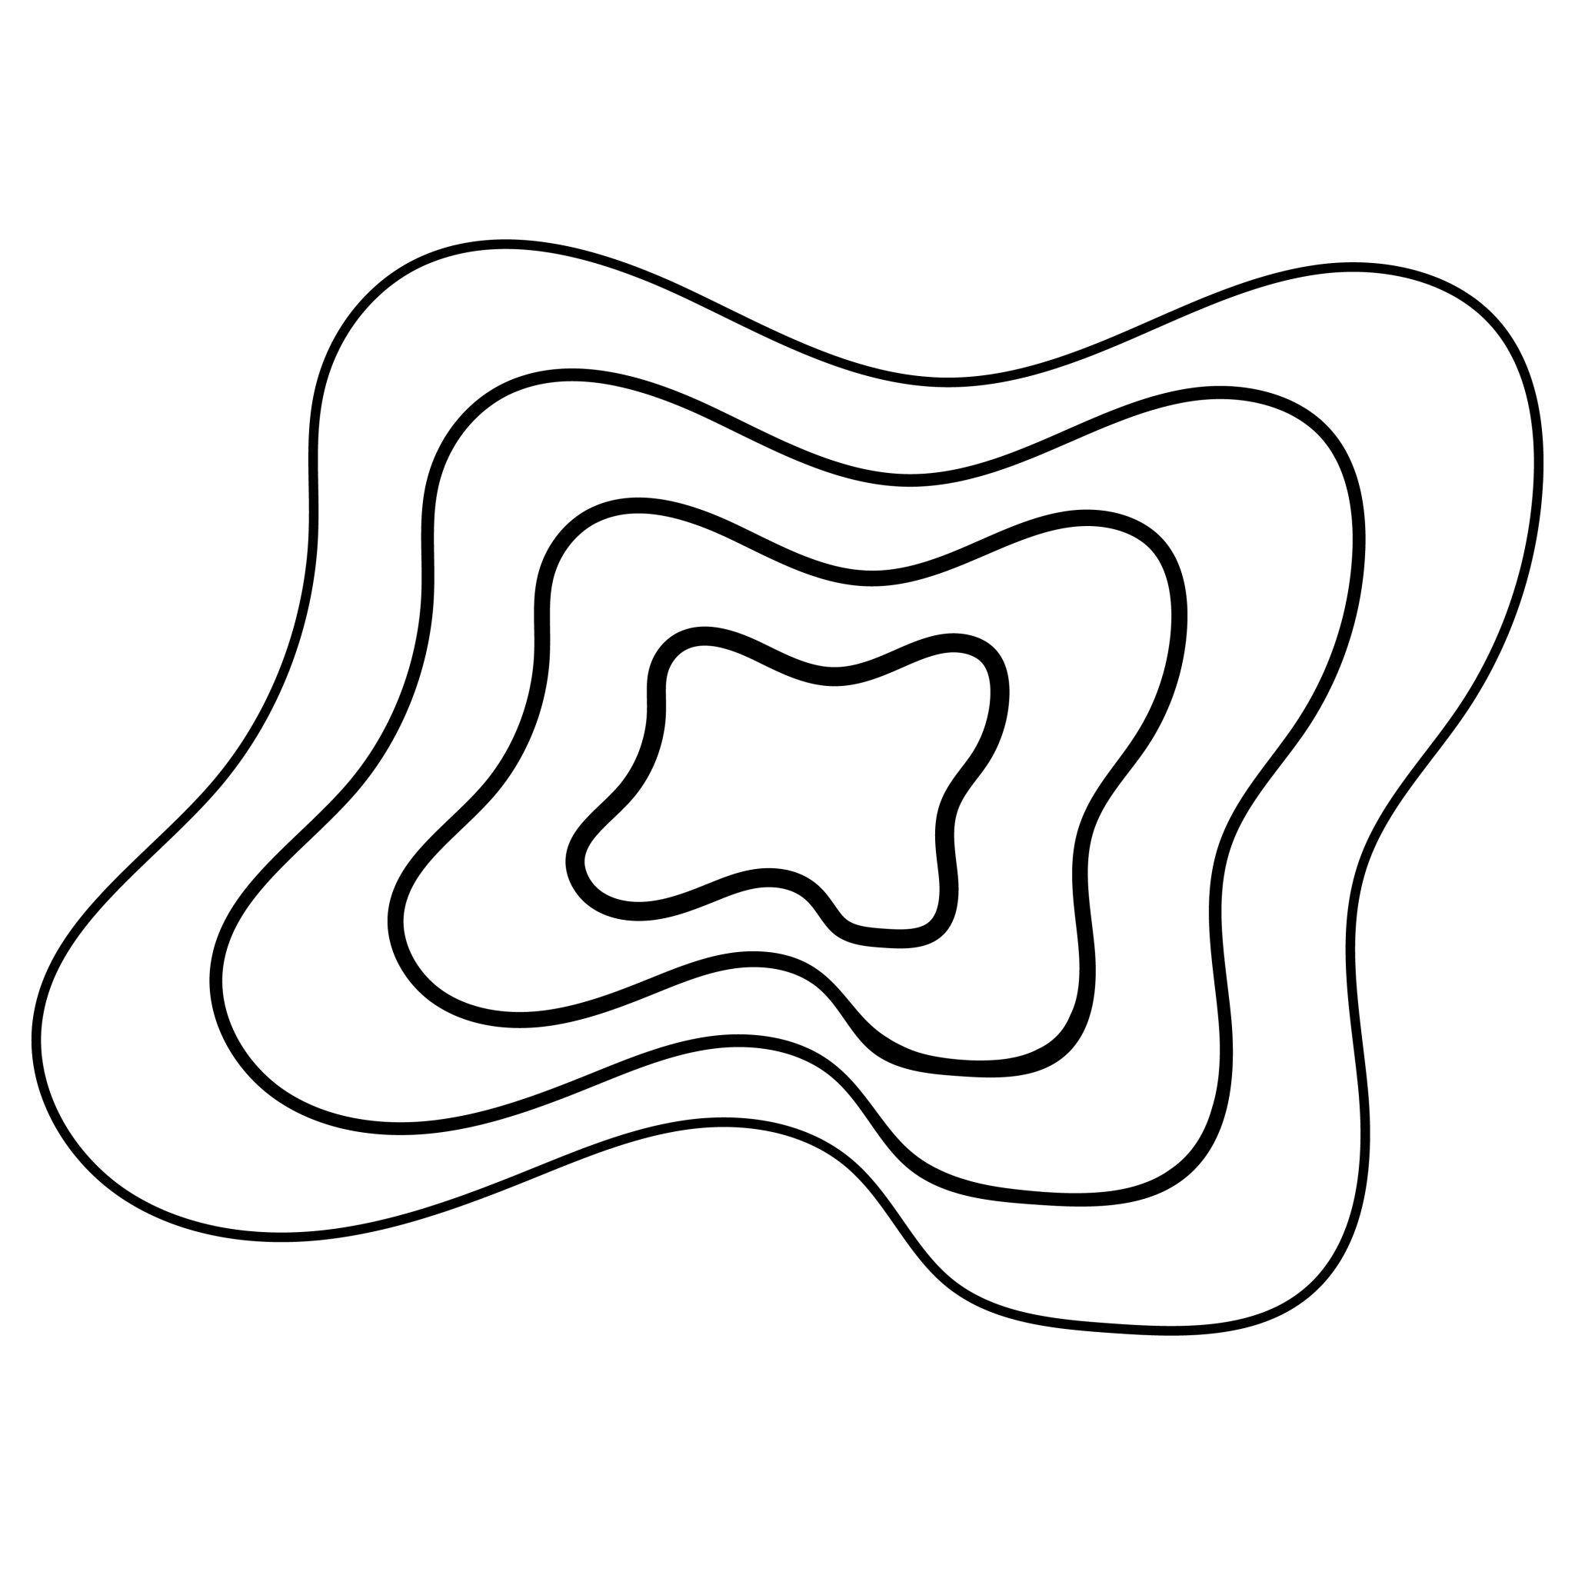
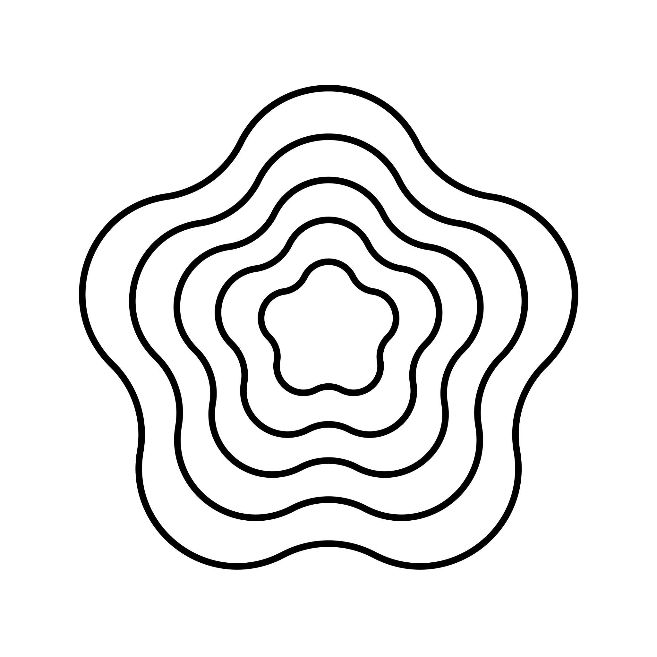
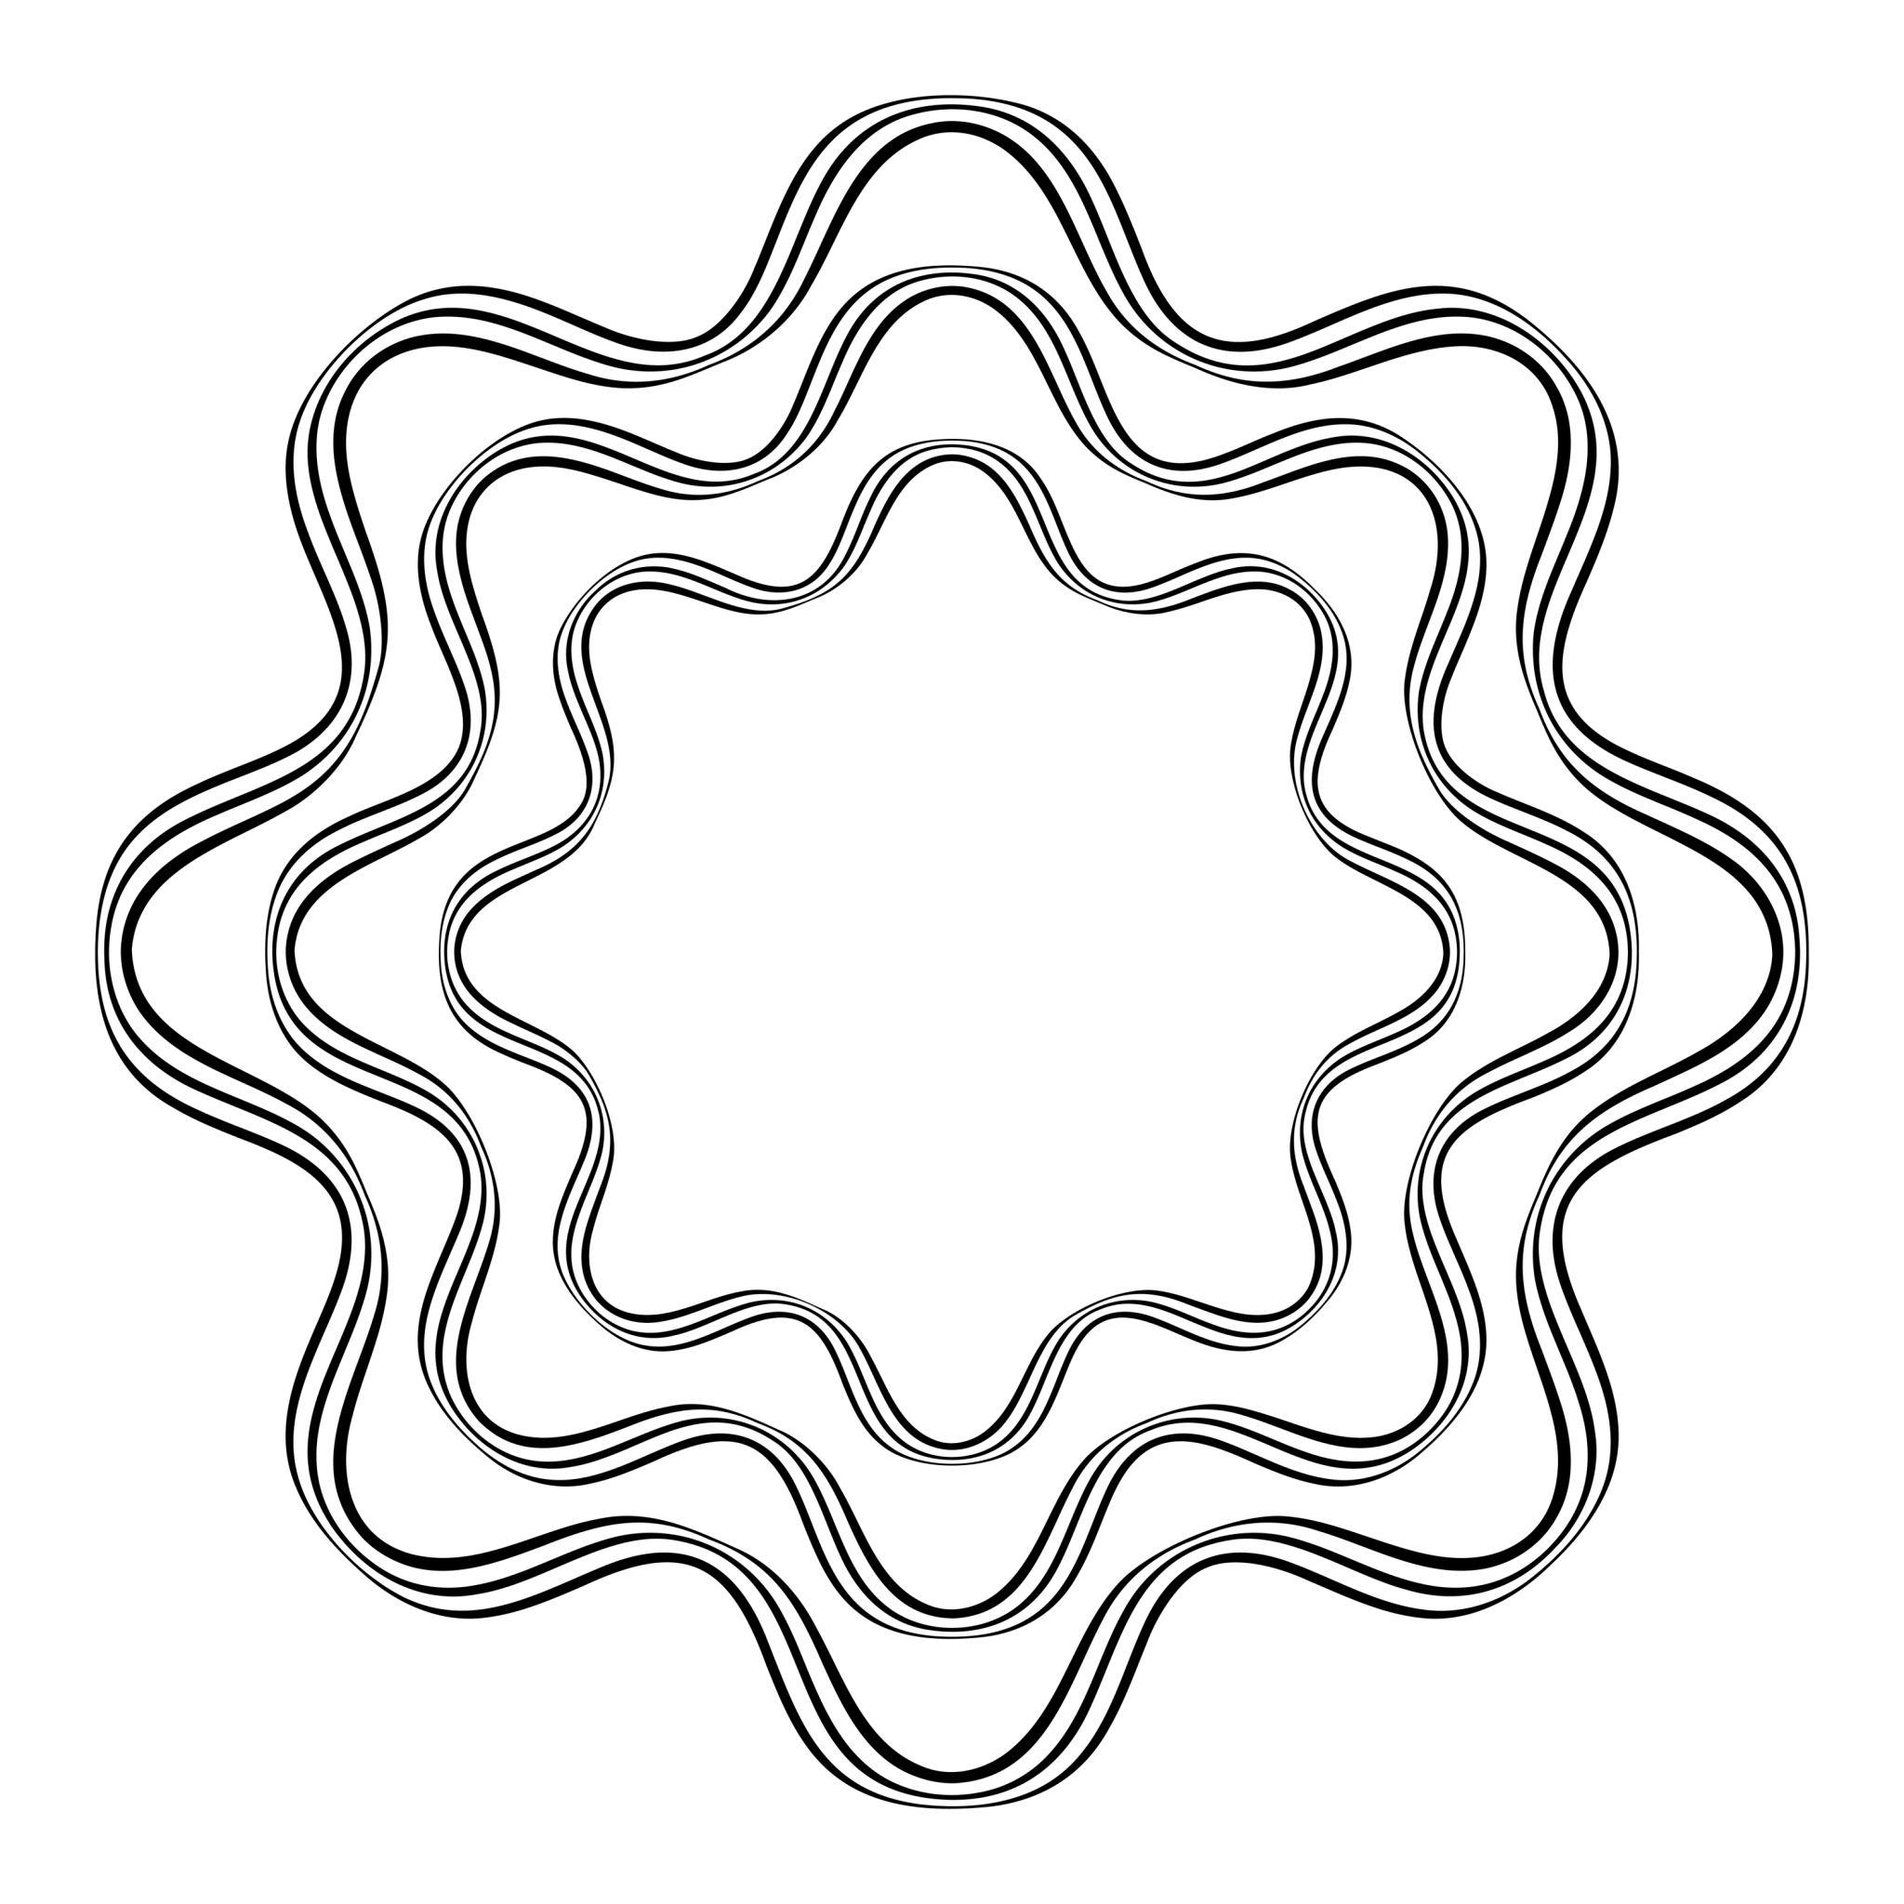
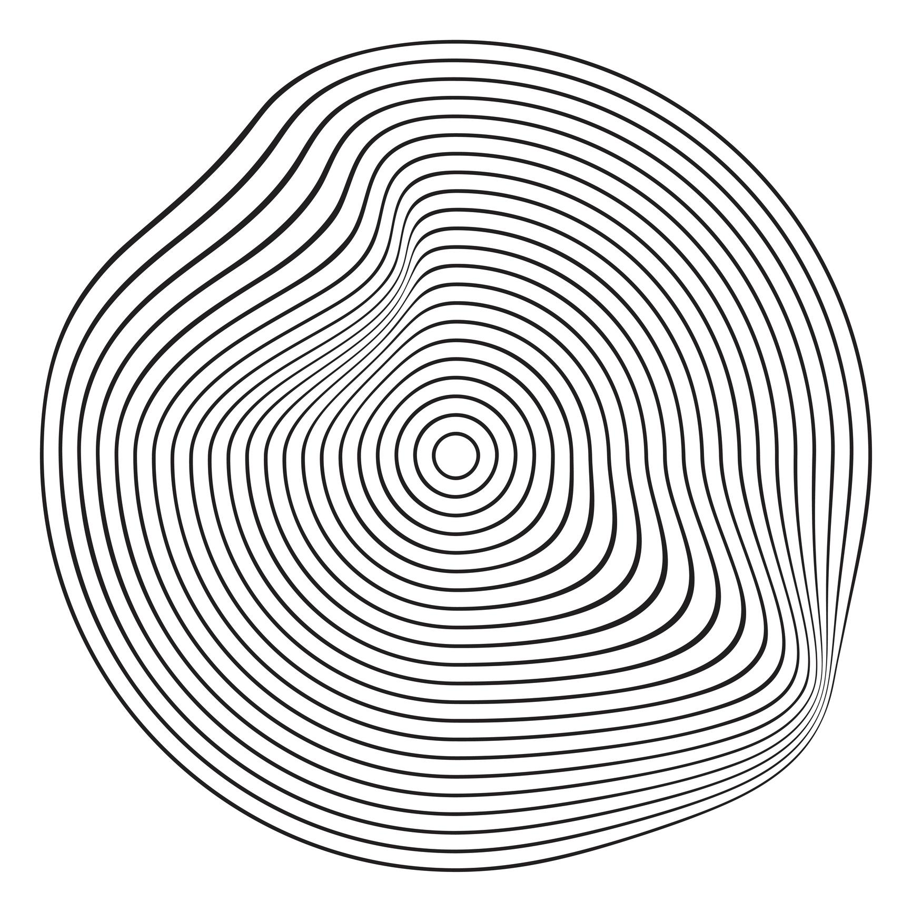
These may create:
- Nested wavy boundaries.
- Wavy ring-like regions.
- Decorative geometric patterns.

8. Organic Wavy Closed Curves
# Source: AI Source: Provided by: [Data Path: Persons Table -> ID Column: 1, Name_En Column: Motasem Essam] -> From: [ChatGPT] on [7/25/2026]
An organic wavy closed curve has an undulating boundary that resembles natural or biological forms.
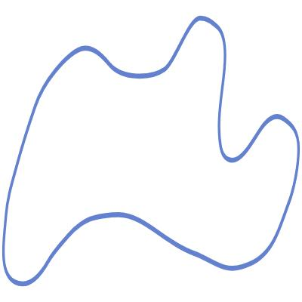
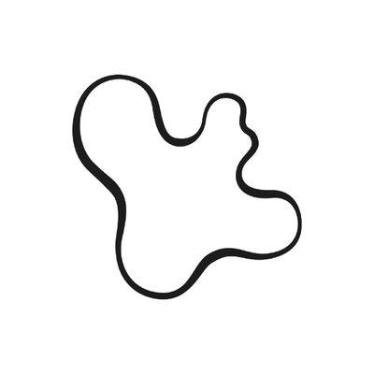
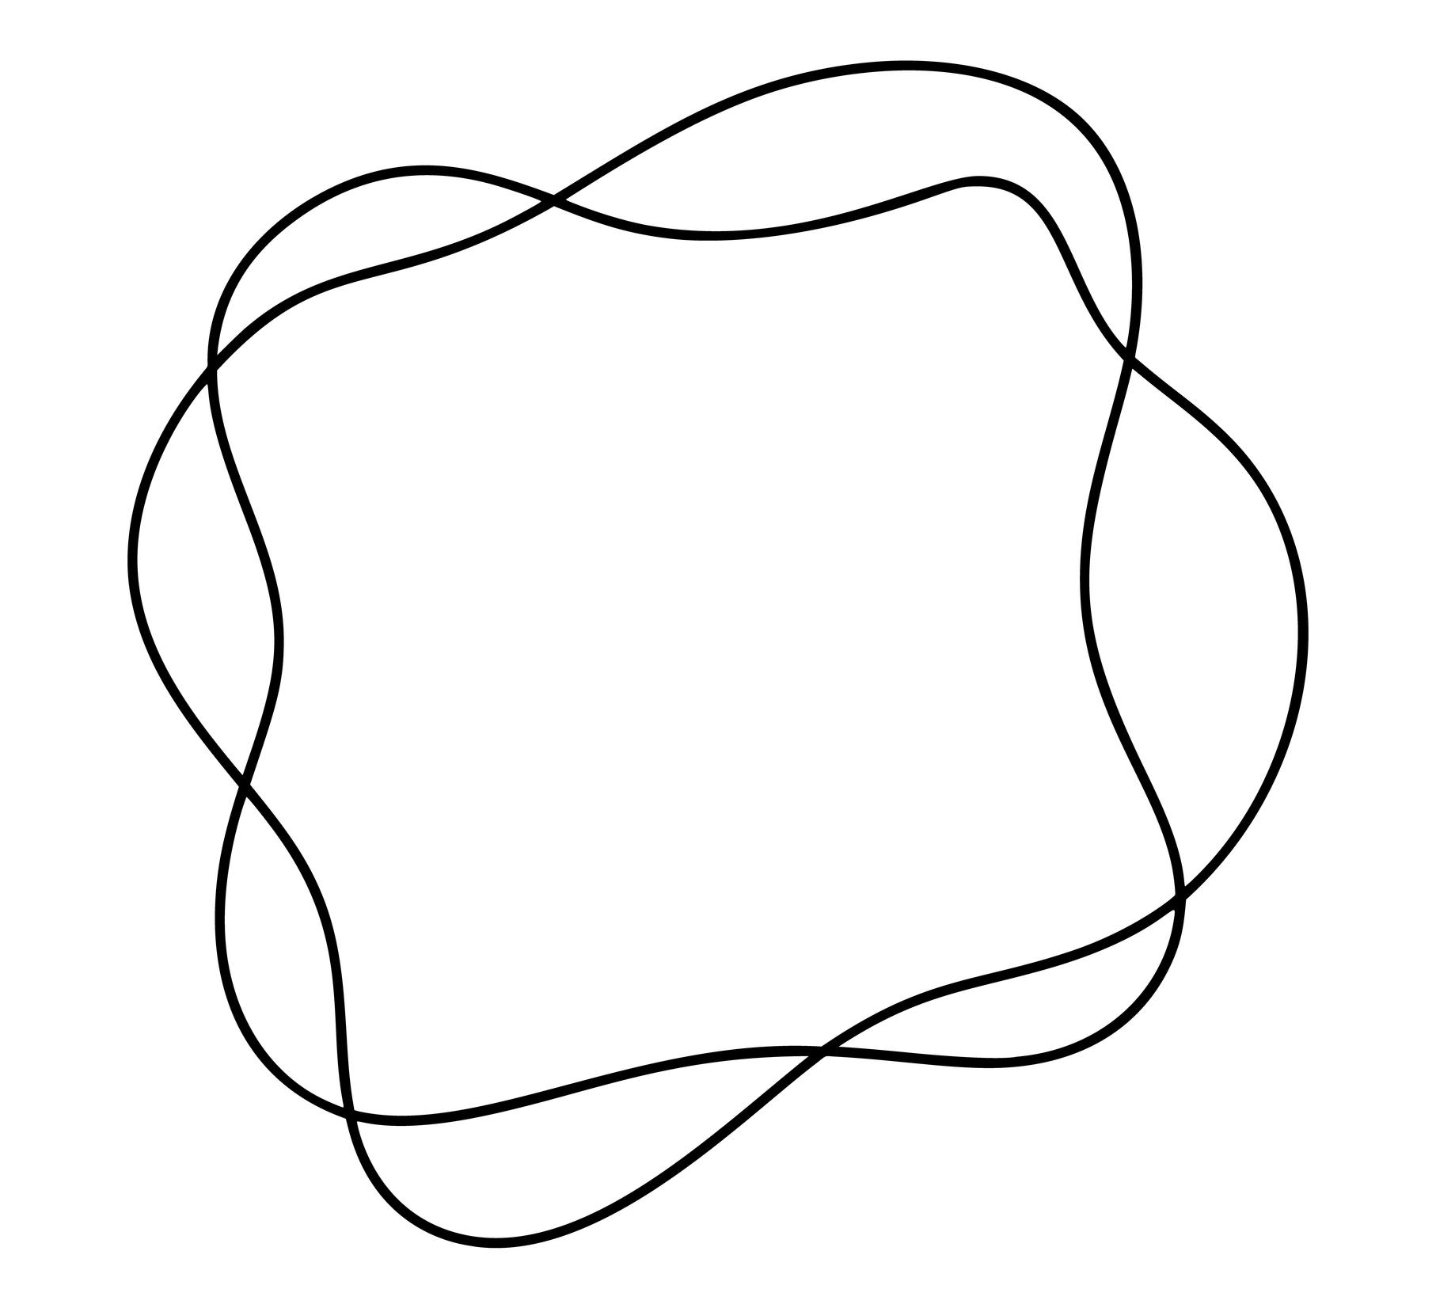
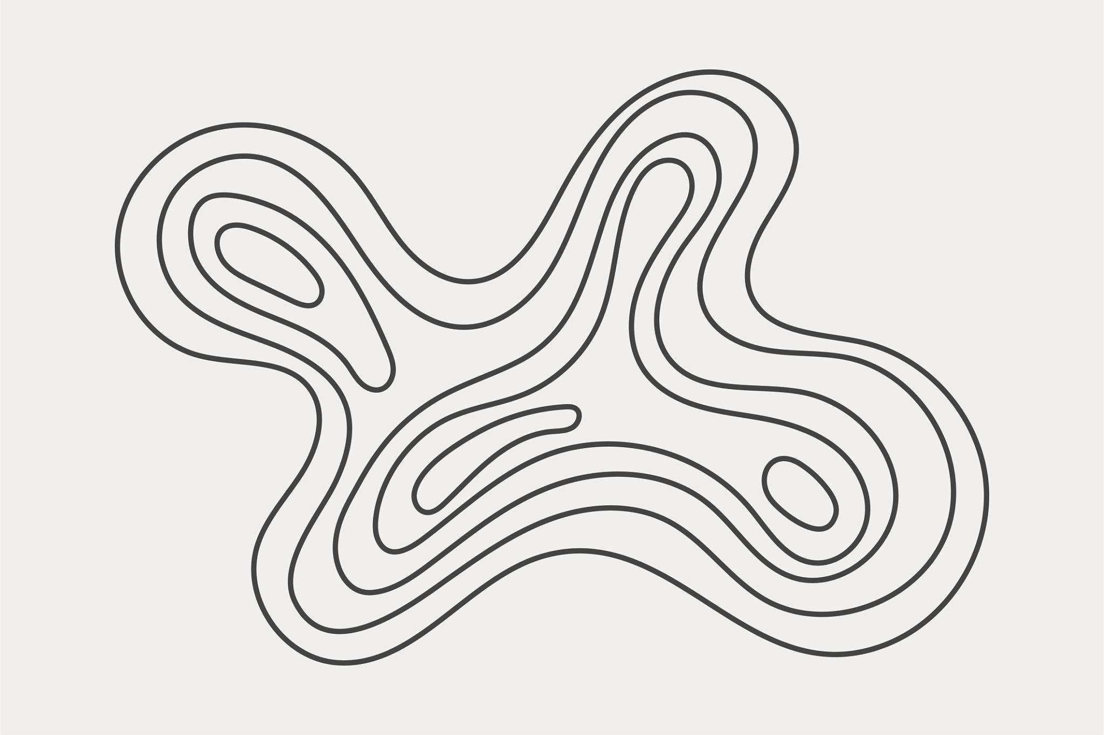
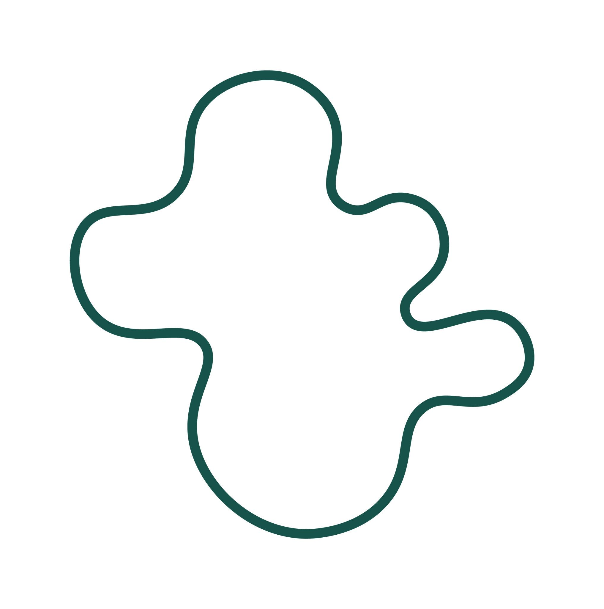
Examples may resemble:
- Petals.
- Leaves.
- Coral.
- Sea organisms.
- Natural growth patterns.
The important distinction is that wavy describes the boundary pattern, while organic describes its appearance.

9. Freeform Wavy Closed Curves
# Source: AI Source: Provided by: [Data Path: Persons Table -> ID Column: 1, Name_En Column: Motasem Essam] -> From: [ChatGPT] on [7/25/2026]
A freeform wavy closed curve is deliberately designed with freely controlled undulations.
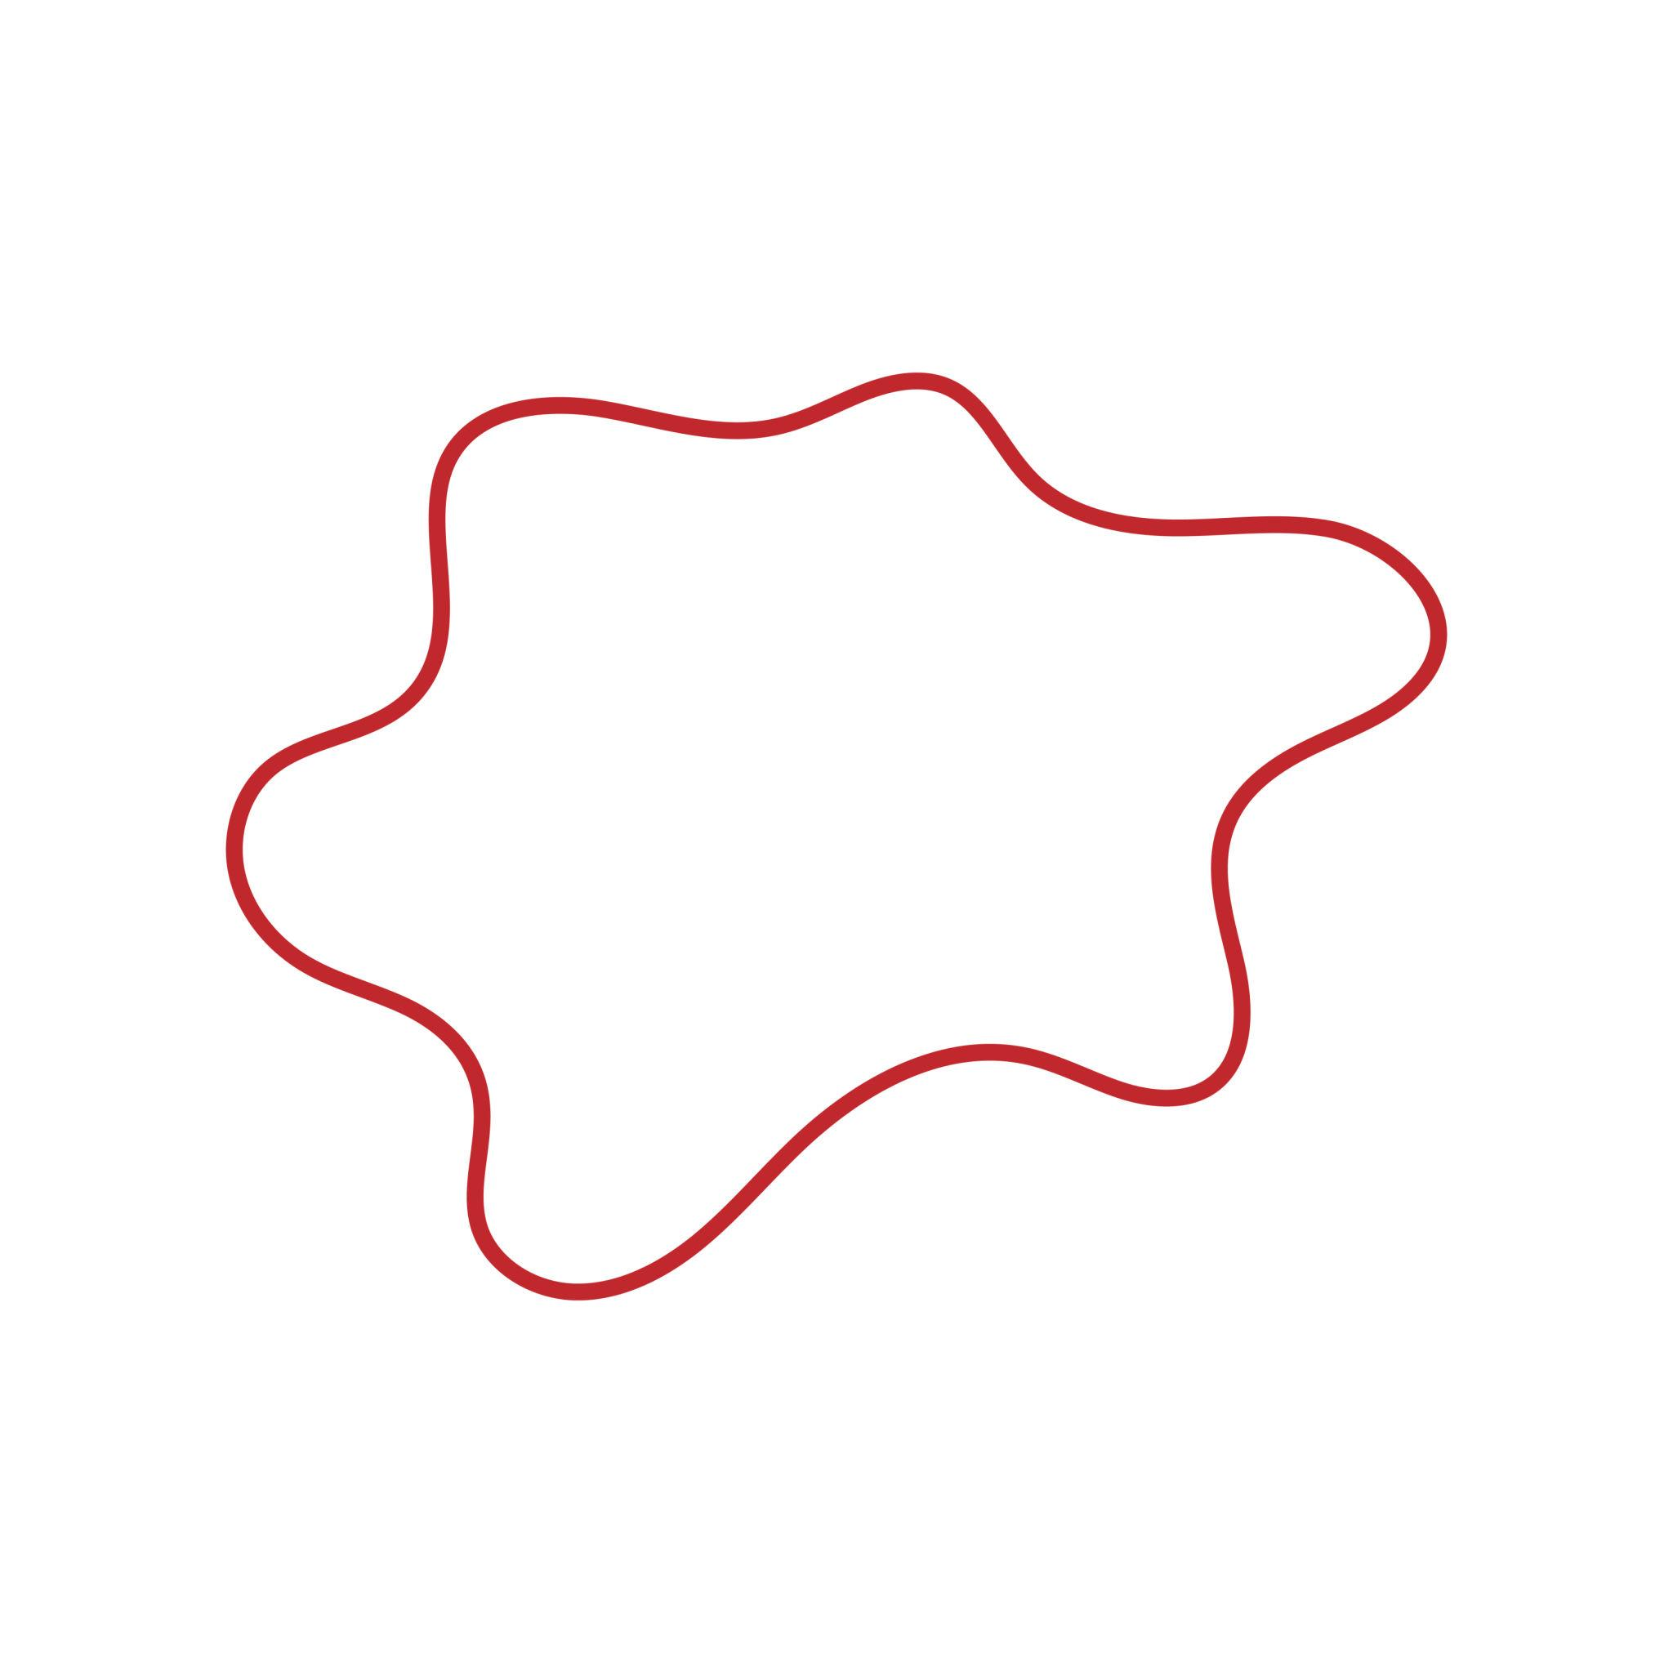
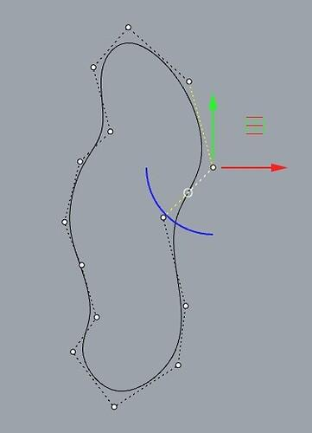
It can be created using:
- Bézier curves.
- Splines.
- Vector paths.
- CAD tools.
- Digital drawing tools.

10. Radial Wavy Closed Curves
# Source: AI Source: Provided by: [Data Path: Persons Table -> ID Column: 1, Name_En Column: Motasem Essam] -> From: [ChatGPT] on [7/25/2026]
A radial wavy closed curve has waves distributed around a central point or center-like region.
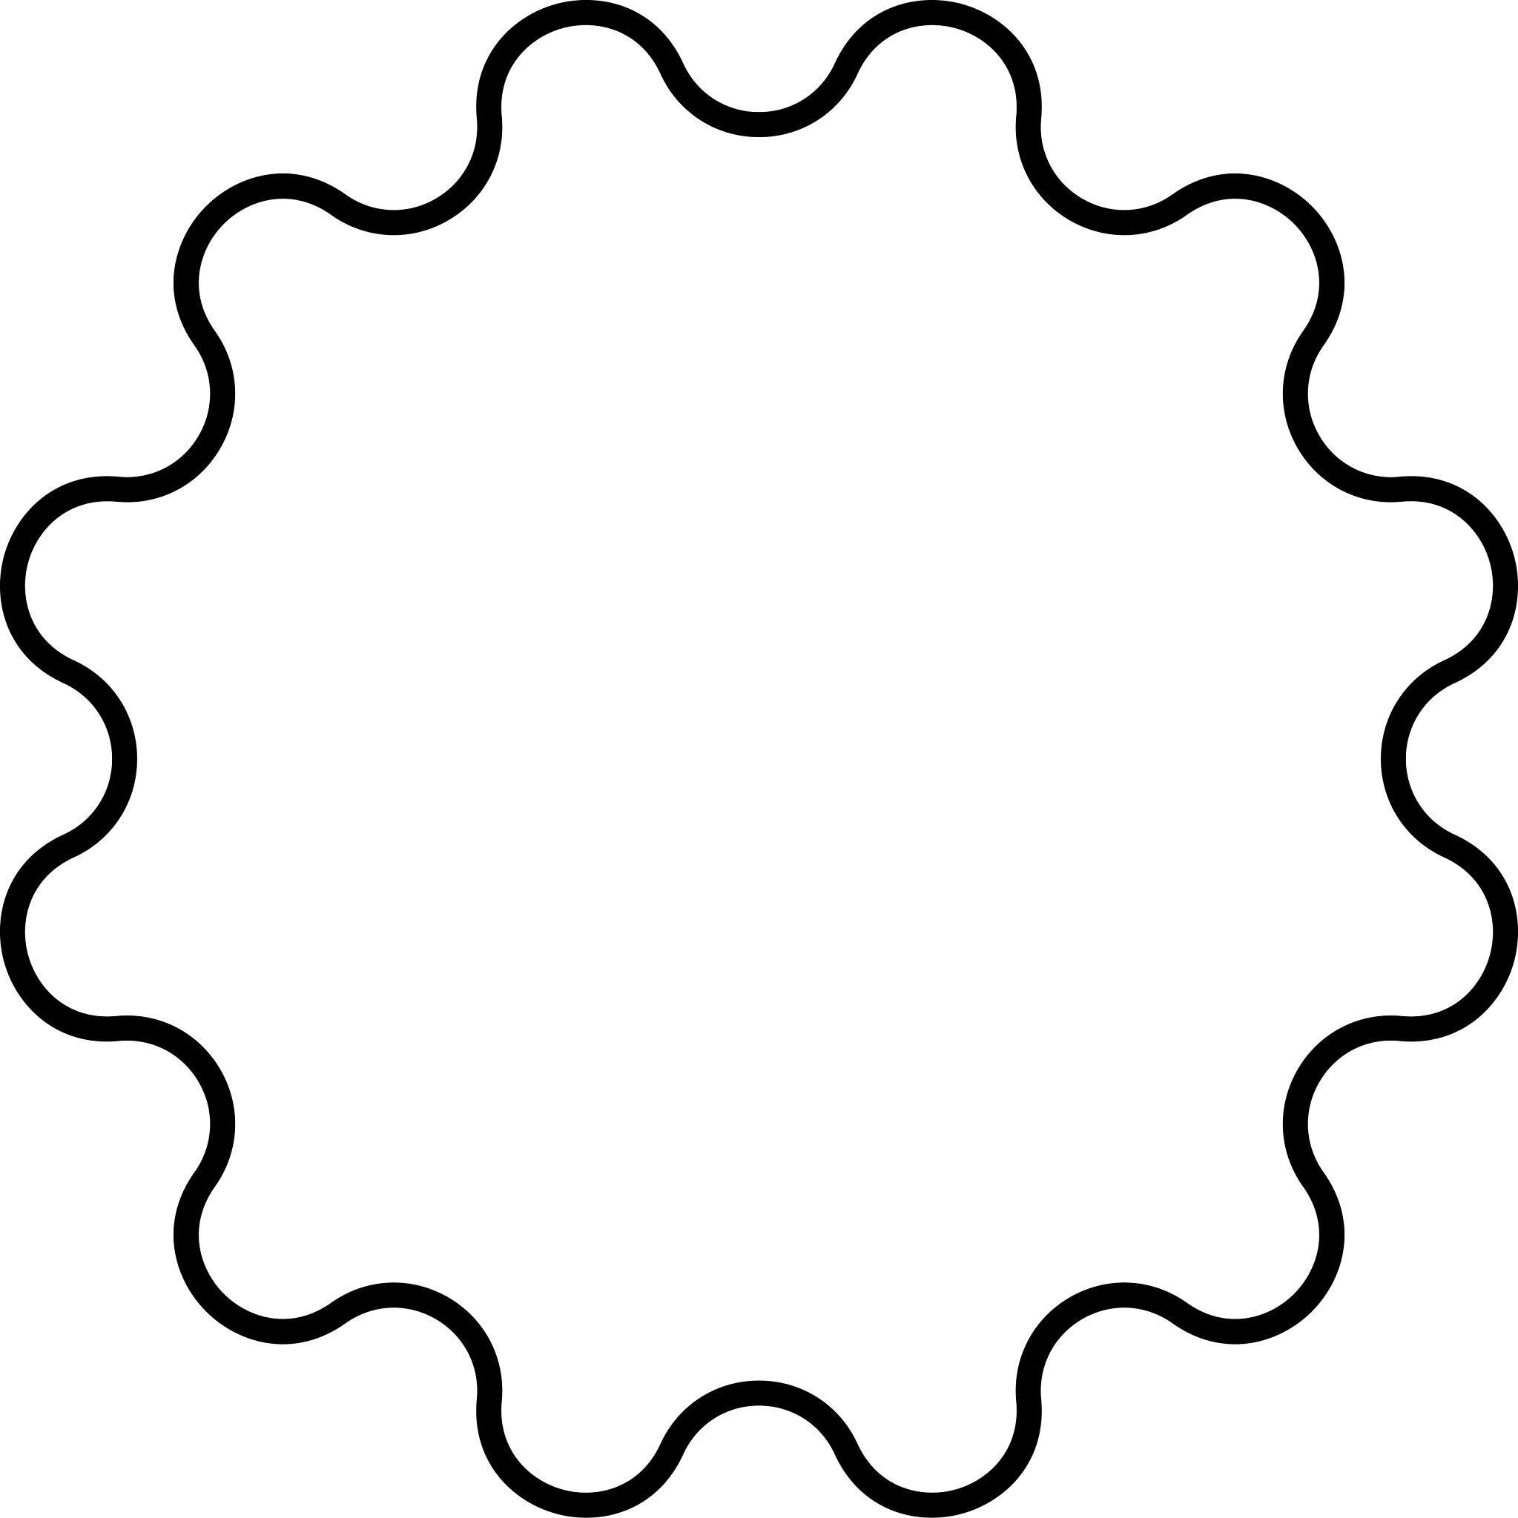
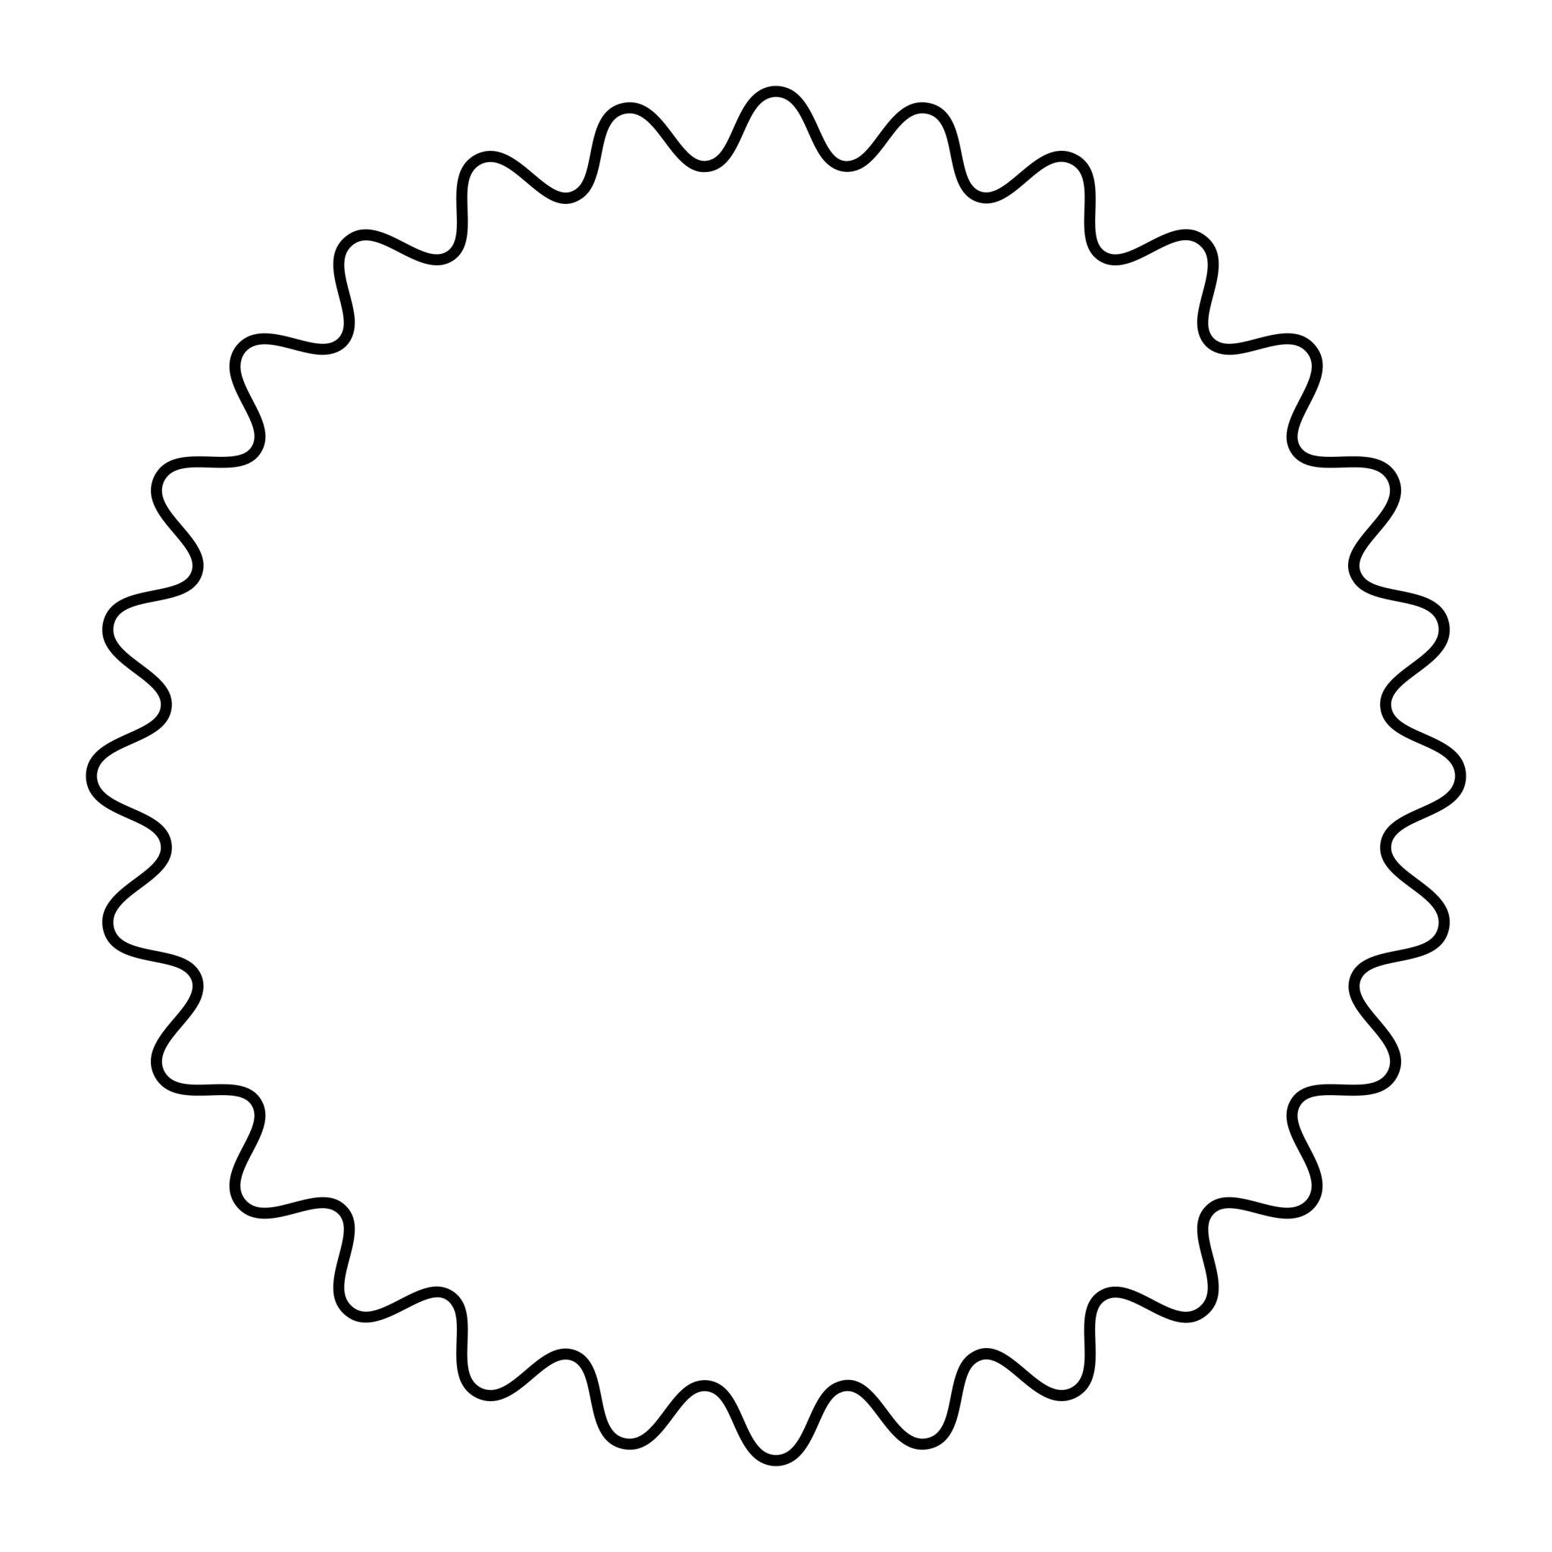
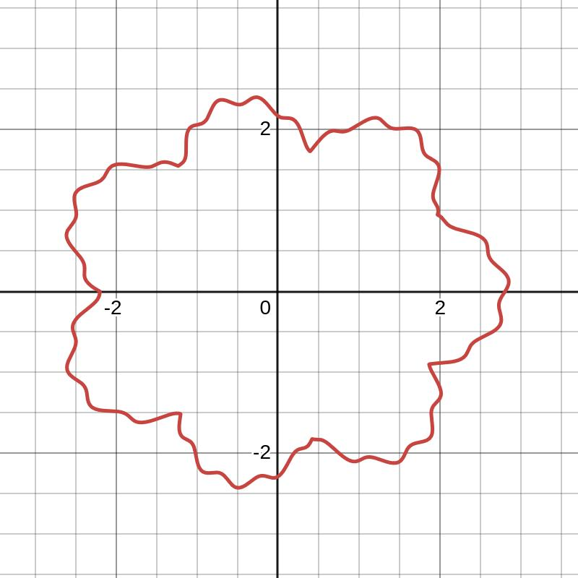
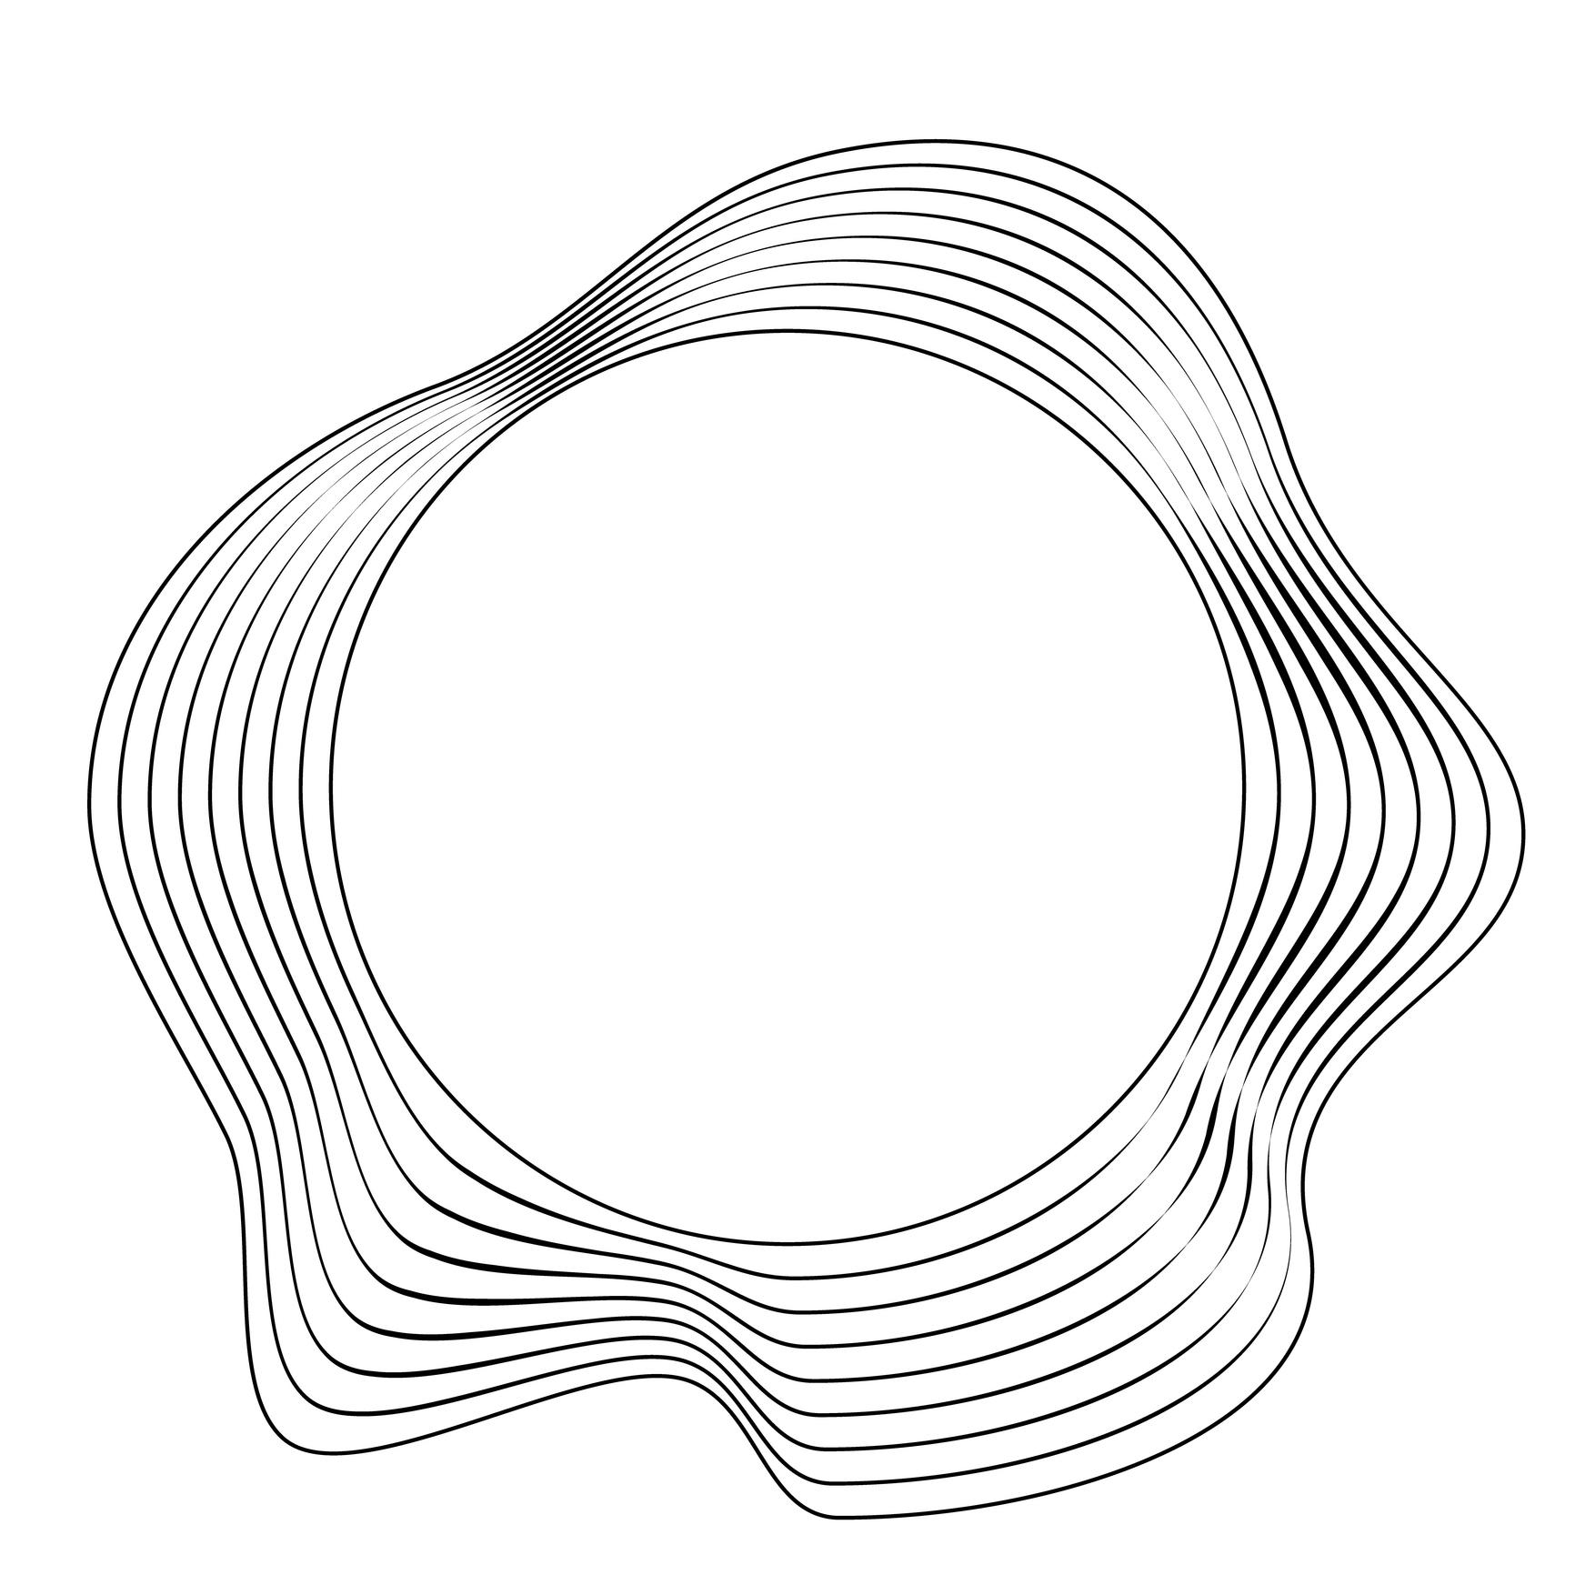
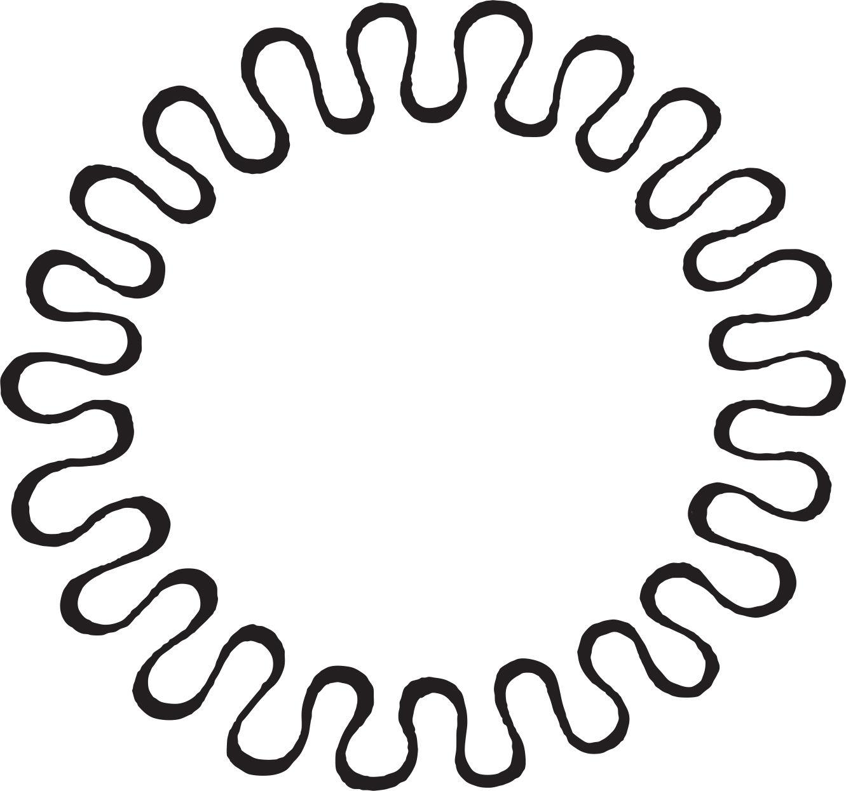
A simplified polar representation can be written as:
$$\boxed{r=f\left(θ\right)}$$
For example:
$$r=a+b\sin\left(nθ\right)$$
can create a closed wave-like radial form for suitable values of $n$.

Regular vs. Irregular Wavy Closed Curves
# Source: AI Source: Provided by: [Data Path: Persons Table -> ID Column: 1, Name_En Column: Motasem Essam] -> From: [ChatGPT] on [7/25/2026]
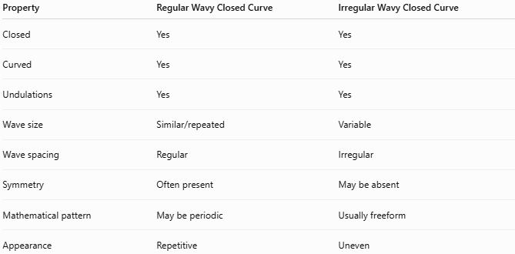
Property | Regular Wavy Closed Curve | Irregular Wavy Closed Curve
Closed | Yes | Yes
Curved | Yes | Yes
Undulations | Yes | Yes
Wave size | Similar/repeated | Variable
Wave spacing | Regular | Irregular
Symmetry | Often present | May be absent
Mathematical pattern | May be periodic | Usually freeform
Appearance | Repetitive | Uneven

Wavy vs. Organic Closed Curved Shapes
# Source: AI Source: Provided by: [Data Path: Persons Table -> ID Column: 1, Name_En Column: Motasem Essam] -> From: [ChatGPT] on [7/25/2026]
These categories can overlap.
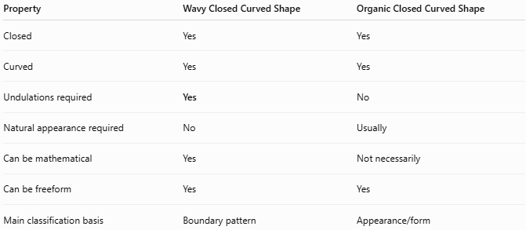
Property | Wavy Closed Curved Shape | Organic Closed Curved Shape
Closed | Yes | Yes
Curved | Yes | Yes
Undulations required | Yes | No
Natural appearance required | No | Usually
Can be mathematical | Yes | Not necessarily
Can be freeform | Yes | Yes
Main classification basis | Boundary pattern | Appearance/form
For example:
- A perfectly periodic decorative wave → Wavy Closed Curve.
- A leaf with slight natural undulations → Organic Wavy Closed Curve.
- An irregular artificial outline with waves → Freeform Wavy Closed Curve.

Wavy vs. Circular Closed Shapes
# Source: AI Source: Provided by: [Data Path: Persons Table -> ID Column: 1, Name_En Column: Motasem Essam] -> From: [ChatGPT] on [7/25/2026]
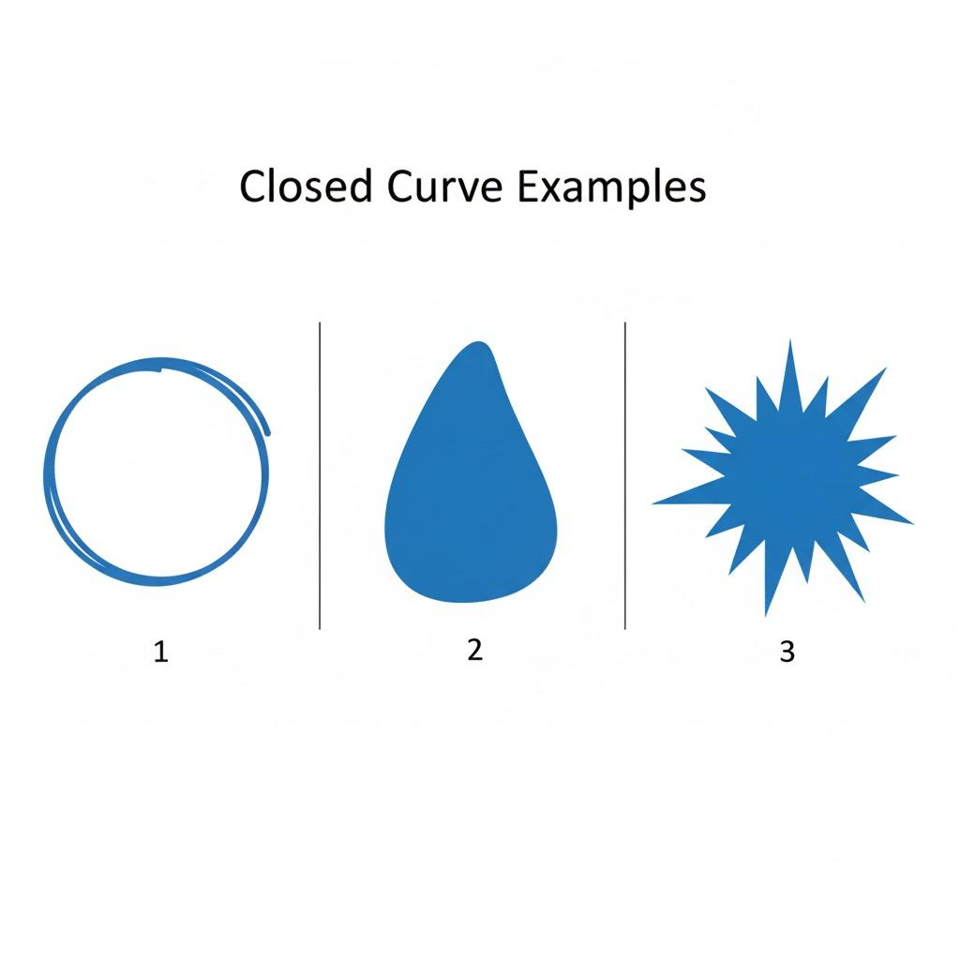
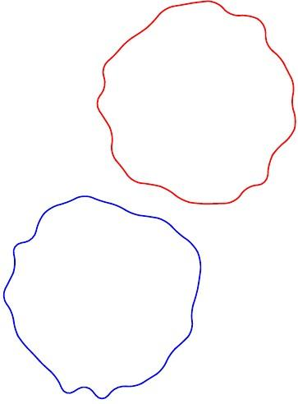
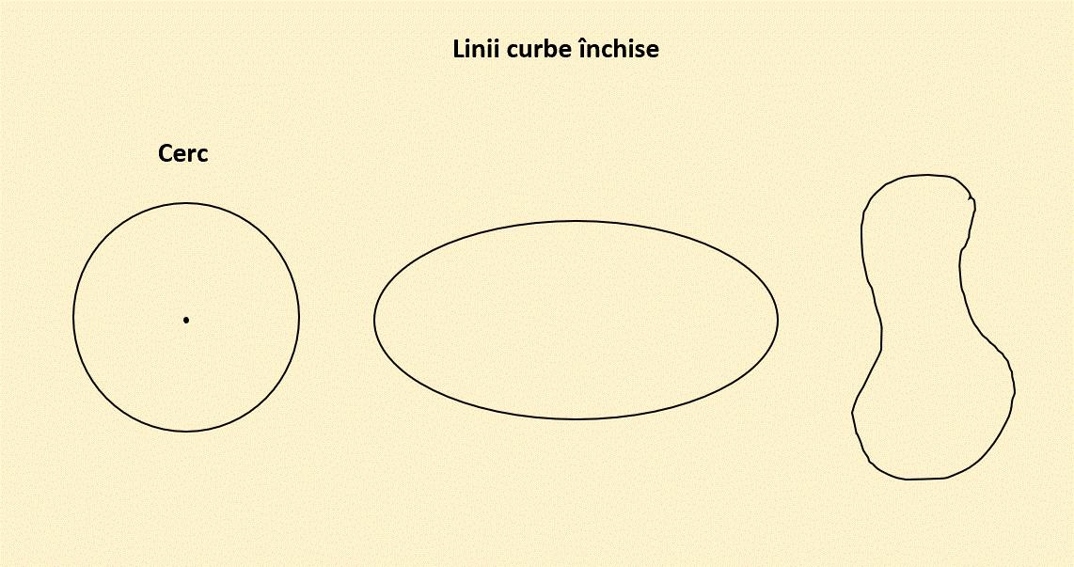
A circle has constant distance from its center:
$$r=\text{constant}$$
while a wavy closed curve generally has a varying distance from its center:
$$\boxed{r=r\left(θ\right)}$$
Therefore:
$$\boxed{\text{Circle}≠\text{Wavy Closed Curve}}$$

Area
# Source: AI Source: Provided by: [Data Path: Persons Table -> ID Column: 1, Name_En Column: Motasem Essam] -> From: [ChatGPT] on [7/25/2026]
Because the curve is closed, it encloses a region.
For a general wavy closed curve, there is no single universal area formula.
For a parametric curve
$$x=x\left(t\right), y=y\left(t\right)$$
the enclosed area can be found using:
$$\boxed{A=\frac{1}{2}\oint{\left(x,dy-y dx\right)}}$$
For a polar closed curve:
$$\boxed{A=\frac{1}{2}\int_{α}^{β}{r^{2}}dθ}$$
when the curve is represented by (r=f(\theta)).

Boundary Length
# Source: AI Source: Provided by: [Data Path: Persons Table -> ID Column: 1, Name_En Column: Motasem Essam] -> From: [ChatGPT] on [7/25/2026]
The total boundary length is the arc length of the wavy curve.
For a parametric representation:
$$\boxed{L=\int_{a}^{b}{\sqrt{{\left(\frac{dx}{dt}\right)}^{2}+{\left(\frac{dy}{dt}\right)}^{2}}}dt}$$
The more pronounced the waves are, generally, the longer the boundary becomes compared with a smoother shape of similar overall size.

Key Points
# Source: AI Source: Provided by: [Data Path: Persons Table -> ID Column: 1, Name_En Column: Motasem Essam] -> From: [ChatGPT] on [7/25/2026]
A Wavy Closed Curved Shape is:
$$\boxed{\text{Closed}+\text{Curved}+\text{Wavy/Undulating Boundary}}$$
It:
- Has a continuous closed boundary.
- Has no open endpoints.
- Encloses a bounded region.
- Contains repeated or variable undulations.
- May be regular or irregular.
- May be symmetric or asymmetric.
- May be organic or artificially designed.
- Can be represented using parametric or polar curves.

Conclusion
# Source: AI Source: Provided by: [Data Path: Persons Table -> ID Column: 1, Name_En Column: Motasem Essam] -> From: [ChatGPT] on [7/25/2026]
Wavy Closed Curved Shapes are closed curved forms whose boundaries contain wave-like undulations. They can be classified further as regular, irregular, symmetric, asymmetric, smooth, lobed, concentric, organic, freeform, or radial wavy closed curves. The term wavy describes the pattern of the boundary, while terms such as organic and freeform describe the appearance or method of construction.

